DON’T THINK OF A GIRAFFE

Lessons for parents on children’s education post Covid19

Blending Eastern and Western wisdom to ensure your children’s academic success in a post-Covid 19 world

CHAPTER 2 - THINKING ABOUT THINKING

Part 4: Eastern vs Western Thinking

The Chinese word for thinking is si. “Si is a broad concept that encompasses understanding, reflection, analysis, synthesis, evaluation, making connections, drawing analogies, making inferences, forming judgements – a taxonomy of thinking.” (Tan, 2015)

“Learning without si leads to bewilderment, si without learning leads to perilousness” Confucius, Analects 2.15

The Chinese term for knowledge is made up of two words xue (to learn) and wen (to ask). The derivation of the English word knowledge is also in two parts – acknowledgment of a superior and action or process. Both derivations suggest an active inquiring mind always asking questions in order to learn and develop knowledge.

The Confucian view of acquiring knowledge first involves research and deliberation then a decision to take action followed by knowledgeable action. Confucius emphasized the importance of learning in mediating the relationship between knowledge and action. (Ching-tien, 2014)

“Study extensively, inquire carefully, ponder thoroughly, sift clearly, and practice earnestly” Zhu Xi (neo-Confucianist 1130-1200)

“Confucius stressed using individual instruction and personal, informal methods while recognising the importance of application and requiring students to apply what they learned by putting their knowledge into practice (Analects 1.1, 6.21, 11.22)” (Smith & Hu, 2013)

Confucius’ view of human intelligence encompassed qualities such as:
- the ability to identify areas of intelligence in others
- self-knowledge
- problem-solving skills
- verbal fluency
- the ability to think actively and flexibly
- the capacity to make healthy personal decisions.
Confucius emphasised the importance of two forms of reflection in achieving learning:
- Reflection on everything that has been learned to synthesise, integrate and look for patterns and commonalities, and
- Reflection on oneself, in order to ensure that such synthesis and integration proceed in an open‐minded, fair and autonomous way, and integrate knowledge with the self, that is, to internalise it until it becomes oneself. (Hye-Kyung, 2003)

From the West the ancient Greeks’ view of knowledge acquisition has a lot in common with the Confucian view:
“Do not then train youths to learning by force and harshness, but direct them to it by what amuses their minds so that you may be better able to discover with accuracy the peculiar bent of the genius of each.” Plato 428 – 349 BC

The closest ancient Greek word to our modern concept of intelligence is nous, but that is closer to the concept of ‘mind’ or the process of thinking. The ancient Greek term for wisdom is phronesis which means a specific type of intelligence relevant to practical action, implying both good judgement and excellence of character and habits, or practical virtue. Phronesis is distinct from phrontis (reflection), metis (cunning), episteme (understanding), gnome (intuition) and techne (technical skill).

In ancient times both the Eastern and the Western traditional views of intelligence were broad and flexible involving reflection and understanding and not just the accumulation of facts. It is interesting to notice how far modern schooling in both the East and the West has moved away from its own intellectual traditions. Schooling these days in most countries is characterised for students by long hours and rigidity, a lack of passion, a focus on grades, the accumulation of facts and being subjected to continuous, pointless, standards-based assessments.
A long way indeed from either the Confucian or ancient Greek views of learning, thinking and the development of intelligence.

In the East and in the West different historical formulations of thinking carried through in the development of language and culture have led to two identifiably different styles of thinking:

Test Yourself:
Which thinking style do you use the most?

The research behind all of these thinking style tests comes from two sources – The Geography of Thought by Richard Nisbett (Nisbett R. , 2003) and Why Asians are Less Creative than Westerners by Ng Aik Kwang (Kwang, 2000).

What follows are four tests for you to do to determine your preferential style of thinking. In each test try and capture your first thoughts, your instinctive or most automatic reaction.

- Of the following three pictures, which two go together best?
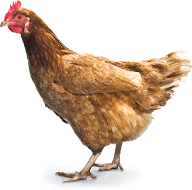

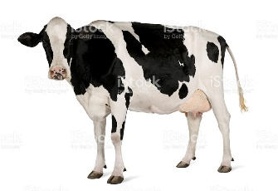



- If you chose the chicken and the cow you are deciding that they go together because they are both animals. Correct?
What you are doing is categorising. In order to find a commonality, you are moving up to the next level of abstraction to see what larger field of description or categorisation any two of these three pictures belong to. You are thinking of the commonality between the two from the point of view of what they represent, that they are two separate members of one taxonomic group - animals.

- If you chose the cow and the grass then you are deciding that they go together because the cow eats the grass. Correct?
What you are doing is focusing on relationships between the things in the pictures rather than trying to classify the pictures themselves. For you, a sense of connectedness between any two things comes from interaction and you are looking for the most common interactions between any two of the three pictures.

- If you chose the chicken and the grass. You have a very creative imagination.

- is more of a Western style of thinking.
- is more of an Eastern style of thinking.

- Look at the first object and decide which group it fits best with – Group 1 or Group 2?

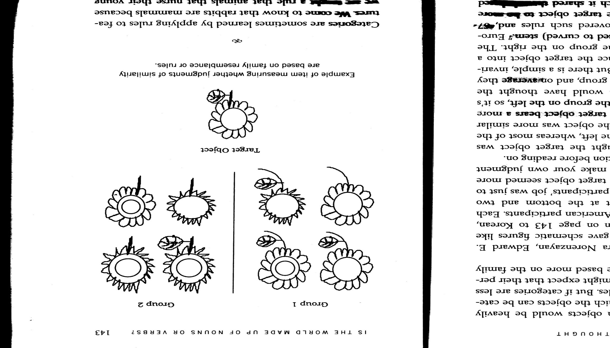
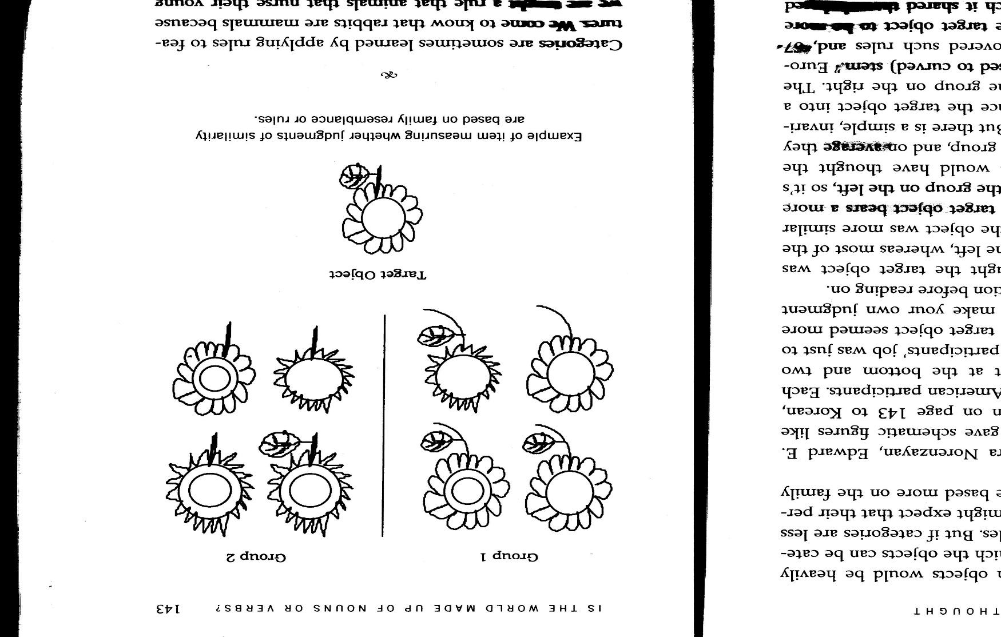

Choosing Group 1 demonstrates more Eastern thinking – choosing ‘shape similarity by group’ over ‘shape similarity by category’.
Choosing Group 2 demonstrates more Western thinking – choosing ‘shape similarity by category’ over ‘shape similarity by group’.

- Look at the first picture below. Then decide, which of the other two pictures does it go with best?

A rubber car tyre
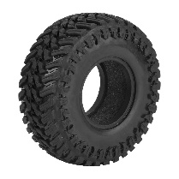

- A wooden wheel
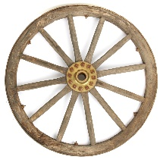

- A rubber ball
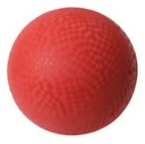

- Is more Western thinking – choosing function over form
- Is more Eastern thinking – choosing form over function

- Look at the following picture. The question is for you to choose which one of these shapes is “at the head of the queue?”

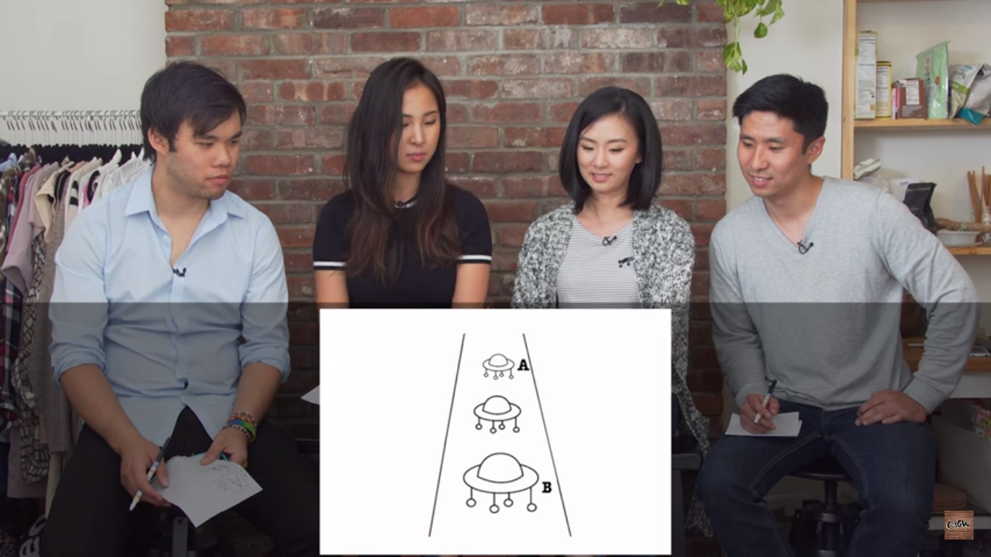

- Is more Eastern thinking – choosing hierarchy over proximity
- Is more Western thinking – choosing proximity over hierarchy

Of course these are just simple fun tests and cannot truly determine your thinking style and your mind is much more complex than any simple test can ever measure but even so, did you see any particular preferences in yourself towards any particular style of thinking?

If you like my writing I have many more articles on my website on the ‘Articles’ page www.taolearn.com/articles-by-lance-king/ and on the ATL page www.taolearn.com/approaches-to-learning/ or you could buy my book The Importance of Failing Well at www.taolearn.com/shop/the-art-of-learning-for-parents-the-importance-of-failing-well/

