DON’T THINK OF A GIRAFFE

Lessons for parents on children’s education post Covid19

Blending Eastern and Western wisdom to ensure your children’s academic success in a post-Covid 19 world

CHAPTER 2: TEACHING THINKING

Part 2: Eastern and Western Students

Much more rigorous testing than I have done here has shown that most people have a tendency towards one style of thinking or the other. Each thinking style is the result of the interaction of culture and philosophy and the historical development of certain prepositions around thinking:

Eastern Thinking | Western Thinking
All behaviour is the result of complex interactions difficult to understand or predict | All behaviour can be understood and predicted
Difficulty in separating objects from environment | No difficulty separating objects from environment
Both A and Not-A can be true simultaneously | Either A or Not-A must be true alone
Cannot understand the whole without reference to the parts | Can understand the whole through analysis of the parts
Field dependent thinking | Field independent thinking
Take into account the effect of all influences | Build logical, evidential arguments to reach conclusion
Find the middle way | Make a decision and stick to it
Think change is likely | Think stability is likely
Reasonable  (Nisbett R. E., The Geography of Thought, 2003) | Rational

But which thinking style is the most successful?
That depends on how you define success.

If Nobel prizes are the pinnacle of academic achievement then there is a definite advantage to Western thinking in achievement:

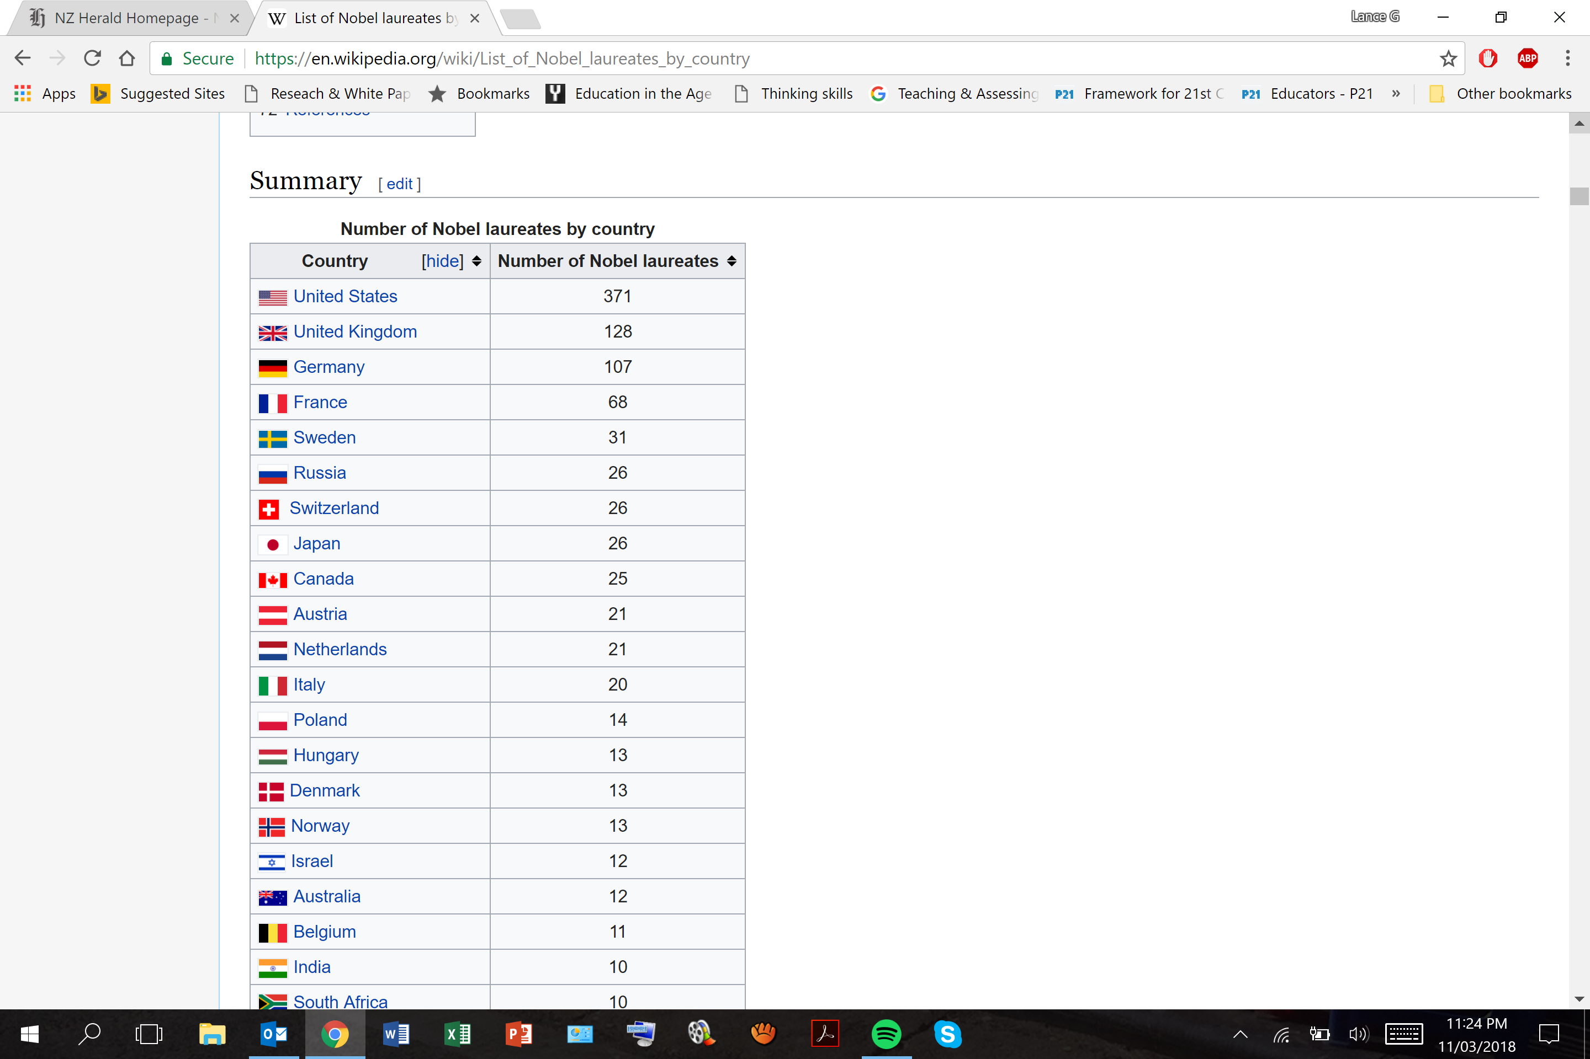

But if creative invention is the pinnacle of thinking then China has won that hands down with many hundreds of modern day inventions accredited to the Chinese including the Four Great Inventions: paper-making, the compass, gunpowder and printing (Needham, 1965).

Traditional educational practice in most Eastern countries has been characterised by exam focused study, long hours of tuition both within and outside of school, lots of homework, intense effort and rote learning. This situation is presently under change in most Eastern countries as I will discuss later in this chapter but the expectation of more passive learning in Eastern schools compared with most Western schools is one of the factors that has produced students with distinctly different characteristics.

The higher regard and respect that Eastern students hold their teachers in when compared to Western students has led to different orientation towards learning in the classroom.
Many Eastern students can be said to have a Receiver orientation towards leaning – this means that they believe it is their responsibility to understand what the teacher has to say. This is different from the prevailing student view in the West which is more of a Transmitter orientation – where students believe it is the teacher’s responsibility to make themselves understood (Nisbett R. E., 2003).
These two orientations lead to different behaviours when students don’t understand what they are being taught. Eastern students will tend to think it is their fault if they don’t understand something and will also not want to risk a possible loss of face by asking a question that others already understand and so will spend considerable amounts of their own time in reading over classroom notes and textbooks and other material in order to gain the understanding they need. Western students on the other hand believe that teachers have an obligation to make themselves understood, they also sometimes view asking the teacher a question as an expression of their own precocious intelligence and they also tend to be more confident than Eastern students in speaking in front of a group. This means that in Western schools, when a teacher reaches a point which goes beyond a students present understanding, they will often ask the teacher a direct question to seek clarification before the teacher moves on. Eastern students are much more likely to seek out the teacher after class and ask a question in person.

These are some of the characteristics that are often attributed to Eastern and Western students:

Eastern Students | Western Students
Learn by listening and remembering | Learn by analysis and critique
Diligent and meticulous | More easy going, relaxed
Prefer exact specifications from teacher | Prefer to find out for themselves
Will work longer on a task if they fail | Will work longer on a task if they succeed
Achievement reflects well on the group | Achievement is a badge of personal merit
Attuned to feelings of others | Strive to look good
Focused on interpersonal harmony | Focused on knowing themselves
Accepting of hierarchy and group control | Expecting equality and scope for personal action

The interesting thing is that although the style of learning attributed to Eastern students is seen as more passive, less analytical and more memory based than that of Western students, it seems to be much more successful.

The most well known international comparison of school students performance is the three yearly survey known as PISA – Programme for International Student Assessment. In the most recent survey in 2015, 540,000, 15 year old students in 72 countries were assessed for performance in Science, Reading and Maths. The top countries across all three subject areas were in order: Singapore, Japan, Estonia, Chinese Taipei, Finland, Macao, Canada, Viet Nam, Hong Kong, China, Korea, New Zealand; with 8/12 of the top positions taken by students from Eastern countries (OECD, PISA 2015 Results in Focus, 2015).

There has been much criticism of PISA by academics which I think has been well answered by Andreas Schleicher in his blog – Are the Chinese cheating in PISA or are we cheating ourselves? (Schleicher A. , 2013), and expanded on with Marc Tucker in his Response to the Brooking Institution Attack on PISA (Schleicher & Tucker, 2013), and don’t need to be gone over here.

In my opinion PISA is a very credible international assessment of 15 year old students’ performance in Maths, Science and Reading. Whether student performance in Maths, Science and Reading is a valid measure of the quality of a country’s education systems or a good indicator of future education or career success for those students are different questions altogether.

But it is not only in PISA that Eastern countries and Eastern students outperform their counterparts in the West. In TIMSS - The International Mathematics Assessment, PIRLS – Progress in International Reading Literacy, the OECD Maths and Science survey of 2014 and the Survey of Collaborative problem solving in digital environments 2015, the top five countries were Singapore, Hong Kong, South Korea, Japan and Taiwan – in different orders.

It is clear that Eastern students do definitely outperform students in other countries on every international test and most interestingly, they do that world-wide, not just when they are going to school in their home country. “Children of immigrants from high-achieving East Asian countries are two-and-a-half years ahead of their Western peers by the time they are 15, even when they are educated alongside them in Western-style schools.” (Jerrim, 2015). Second generation immigrants to Australia from East Asia, mostly of Chinese origin, scored on average 102 points more than Australian born students in PISA 2012 (Weale, 2014). In England, in 2013, children of Chinese immigrants achieved the highest GCSE scores of any ethnic group (Easby, 2014). Asian Americans have also been subject to much study. According to Professor Yong Zhao, in the USA (Asian Americans) “Have three to five times their proportionate share of college faculty, architects, scientists, teachers, engineers and physicians. They are overrepresented at America’s most prestigious universities, constituting roughly 50% of the freshman at the university of California at Berkeley… and they score higher on the SAT and the ACT especially in Math.” (Zhao & Qiu, Model Minority Myth Revisited: An Interdisciplinary Approach to Demysitfying Asain American Educational Experiences, 2008)

The question remains then – Why do Eastern students do so much better than their Western counterparts in similar academic tasks?

If you like my writing I have many more articles on my website on the ‘Articles’ page www.taolearn.com/articles-by-lance-king/ and on the ATL page www.taolearn.com/approaches-to-learning/ or you could buy my book The Importance of Failing Well at www.taolearn.com/shop/the-art-of-learning-for-parents-the-importance-of-failing-well/

