LALATAT
ATL/21ST-C Skills for Student Success in a Post-Pandemic World

Academic Support:
lance@lalatat.com
LalatatLance
Eric Lauzon – eric@lalatat.com
Bianca Duceppe – bianca@lalatat.com
Sales:
Rohan Jarvis - rohan@lalatat.com
Technical Support:
info@lalatat.com

Lessons learned from Covid19
- 825,000,000 students affected by schools closures (January 2021)
- Stress, anxiety, loneliness and depression of students and teachers at record high levels
- Loss of 1/3 of year of schooling future GDP 1.5% lower (in USA) $15.3trillion loss effect on future economy
  - (Hanushek & Woessman, in The Impact of Covid-19 on Education, Andreas Schleicher, 2020)
- Some students have thrived in the remote learning environment but the majority of have not
- The most successful students are those with the best skills of remote self-management

Teachers need:
- comprehensive training in the design of engaging, independent, remote-learning lessons
- to be very familiar with every digital platform that will help students learn their subjects – both the free and the paid sites
Schools need:
- to invest in subscriptions for teachers in all the best school subject sites and delivery platforms
Students need:
- training in all the skills they need to become effective, remote, self-managed learners

Any ATL/21st-C skills programme is all about focusing students on factors to improve success
that are in their control.

Changing workforce trends:
McKinsey Global institute, 2018:
- 50% of current work activities are technically automatable
Future of Jobs Survey 2020, World Economic Forum:
- 84% of employers are digitizing working processes with 44% of workforce expected to operate remotely by 2025
- 94% of business leaders expect employees to pick up new skills on the job
Future of the Classroom, June 2019, Google:
- 91% of CEOs are strengthening soft skill training alongside digital skills
Industry 4.0, January 2020: Deloitte:
- ‘soft skill’ intensive occupations will increase to 63% by 2030
- 80% of CEOs are creating a corporate culture of lifelong learning

“The world economy no longer rewards people just for what they know,
the world economy rewards people for what they can do
with what they know”
Andreas Schleicher, PISA, OECD
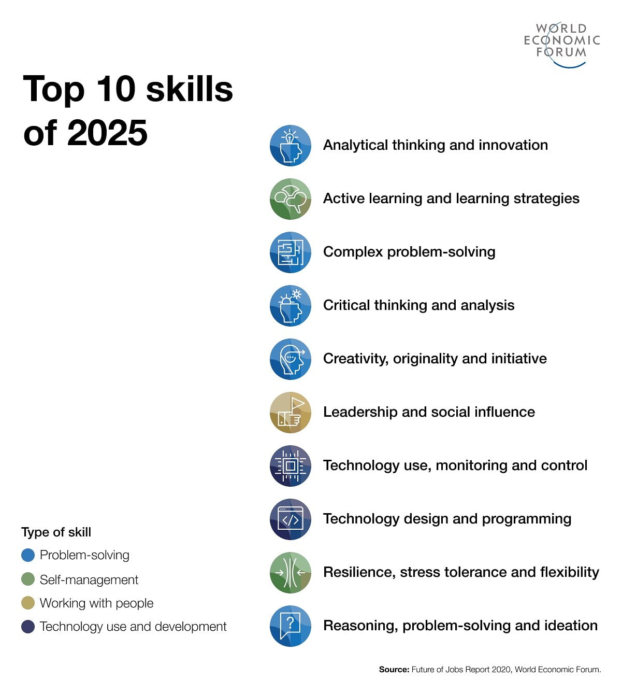
Aim and purpose of any ATL/21st-C skills programme:
Aim – for teachers:
- to give students control over their own academic, social & emotional success
- student mastery of all the skills underpinning the development of knowledge, understanding, character and the self-management of learning
Purpose – for schools and parents:
- to give students training in all the skills they need to take maximum advantage of every career and learning opportunity in their future

Helping students to become successful, self-managed (remote) learners needs to be a top priority for 2021-22.
Key ATL/21st-C skills of self-managed learning:
- Time and task management
- Self-motivation, overcoming procrastination, generating urgency, persevering
- Setting up their home study environment, concentrating, eliminating distractions
- Creating and maintaining digital collaborations, forming study groups
- Writing goals, setting goals and achieving goals
- Self-assessment, learning from mistakes, failing well
- Effective searching and researching, choosing appropriate media, recognising media perspectives and bias, IP rights, referencing and copyright
- Summarising key points from text, audio and video sources
- Developing evidence based arguments, creating multi-media presentations

All skills frameworks can be found on my personal website as downloadable spreadsheets:
Go to www.taolearn.com / ATL Resources / Process-Skills FRAMEWORKS for use with LALATAT.com
You will need this one only for this workshop:
- Core Skills for Remote Self-Managed Learning
You will also need to have gone to lalatat.com, registered for lalatat.online, received your token, and logged into lalatat.online – Remote Learning Portal

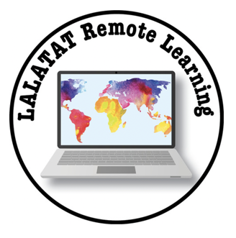

From this point onwards I am replacing ATL/21st-C Skills with Process-Skills.

Task 1: Get familiar with learning all the key process skills:
- The 19 strands of the Remote Learning portal are divided up between 16 groups of 1-4 people per group (mixed programme and grade/year levels) as follows:
- 1b. Time and Task Management
- 1a. Write Goals + 1c. Achieve Long Term Goals
- 2a. Learning Preferences + 4a. Self-assess Learning Skill Development
- 2d. Create a Study Group + 7h. Digital Groups
- 3a. Concentration and Mindfulness
- 3c. Self-Motivation
- 3d. Failing Well
- 3f. Perseverance and Procrastination
- 5g. Create Summary Notes from Text
- 5h. Create Summary Notes from Presentations
- 6b. Create Presentations
- 6c. Media Options and Choices
- 9c. Effective Searching
- 9h. Evaluate Sources for Bias
- 9j. IP Rights, Academic Honesty and Referencing
- 10b. Develop Evidence-Based Arguments

- Each small group has one or two strands to work on
- Go to lalatat.online on your laptops, open up the Remote Learning portal, find your strand(s), and work through all the exercises in your strand or strands
- Fill in all the answers required in the exercises as thoroughly as you can from a teacher’s point of view or pretend you are a student
- You can work together and share your answers but you need to all add in your own data individually
- Note down how long it take you to complete each exercise

How to teach process-skills?
- Explicitly – specifically teaching process-skills themselves, either within or outside of subject based lessons
  - (see my IB Conference presentation on this topic at https://www.youtube.com/watch?v=6pA2nsZEMAk
- Implicitly – teaching process-skills by using them with subject content in normal subject lessons
- Both methods are useful

Video 1: ATL skills taught explicitly at Tokyo International School – PYP.
https://www.youtube.com/watch?v=XpIybqQle98&t=3s

Video 2: Thinking and learning skills taught explicitly in middle school in Helsinki, Finland
https://www.youtube.com/watch?v=4ipk3dWsrXE

Video 3: Design thinking skills taught explicitly in high school in Michigan.
https://www.youtube.com/watch?v=l7-MVYjZYOE&t=139s

Explicit teaching as the first stage in process-skill development:
Novice  Watch | Learner  Copy | Practitioner  Do | Expert  Teach/Share
Can watch others performing tasks and using the skill  High levels of scaffolding from teacher needed | Can copy others performance of the skill  Medium level of scaffolding needed | Can demonstrate the skill on demand  Minimal teacher scaffolding required | Can teach others the skill  Self-regulating  No teacher scaffolding required
Introduce – raise awareness of the skill, have the students experience using the skill for the first time |  | Practice - allow for practice and improvement | Master - enable independent use of the skill
Explicit teaching – introduce the skill by teaching with simple content | Implicit teaching – develop the skill by using it with subject content
Increasing self-management of learning

Developing process-skills – what do you want your students to ‘do’?
Process-skills are all about the ‘doing’ – the tasks that students need to undertake to help them understand concepts and information and complete assessments.
- Which Remote Learning (RL) skills do you want your students to practice and develop, when?
  - to help develop understanding in specific units or lessons?
  - to help them complete specific homework tasks?
  - to help them to complete specific formative and summative assessments?
- Managing their time and tasks well?
- Working well with other students in a digital group?
- Making good notes from text or podcast or video presentation?
- Researching well– finding, comparing and contrasting information, analysing information for perspective and bias?
- Creating an evidence based argument?
- Designing and delivering their own presentations?

How to teach and develop process-skills implicitly, explicitly and/or remotely
- Analyse your unit plans and lesson plans and decide for each one which process-skills strand from the LALATAT RL portal will most help your students to improve their understanding of the subject matter and complete their assessments:
- Make sure all your students have access to the RL portal and:
  - set the RL exercise for online homework for the night before a lesson, have students reflect on the key points at the beginning of the lesson then have them practice the skill in the lesson (explicit remote learning implicit practice)
  - have students complete the RL exercise online at the beginning of a lesson then use the skill in the lesson (explicit teaching implicit practice)
  - build the lesson around the RL exercise (implicit teaching)

Task 2: Remote Learning portal exercises – engaging students at different grade levels
- Share ideas in your group of ways in which each RL portal exercise in your strand could be used at each of three levels - elementary, middle and senior school.
- Think about what you learned from doing the exercises yourself. How could students best practice using them?
- At which grade level is each exercise most appropriate? Could it be made simpler for more junior classes? More complex for seniors?
- Can you link each exercise to specific subject lessons or topics? Are there appropriate times when each exercise could be taught explicitly or could be used as part of teaching a particular subject lesson?
- Any ideas at all that would help other teachers to use your strand exercises in their lessons would be helpful
- Open up the Core Skills for Remote Self-Managed Learning spreadsheet, find your strand and write in your ideas for how each exercise could be taught at each of the three levels of school – write any ideas in the cells under the appropriate Grade level – change the size of cells as necessary

Standards and evidence of process-skill development and proficiency
- Process-skill proficiency is only demonstrated through actions taken by students in learning all their normal subjects
- Process-skill standards are standards of performance (what will students be able to do?) not standards of knowledge or understanding and as such are quite different from assessment standards for subjects
- The standards of process-skill performance expected of students can be tied to:
  - Major assessment tasks they are expected to complete at different levels e.g. in an IB school the Exhibition, Personal Project, Extended Essay; in a Cambridge school, IGCSE, GCSE, AS & A-Level exams
  - Critical stages where a significant ‘step-up’ in academic performance is expected in the following year e.g. between junior and middle school, between middle and senior school, at the end of Gd12/Yr13
- Students achieve proficiency in different process skills at different times
- It is not necessary to have process standards at every Grade/Year level
- First define your Mastery standard then use ‘backwards design’ to create other standards at critical points in students’ development

Task 3: Remote Learning skills – Mastery standards
- Use the Mastery definition from your strand in the Remote Learning portal of lalatat.online, or create your own
- Discuss and decide by which Grade level you expect students to achieve that standard
- Write these in the Mastery columns in the Standards of Performance section of the spreadsheet:
    - “The highest independent performance of this skill we expect to see is…”
    - Students will achieve Mastery by Grade level…

Task 4: Standards of Remote Learning skill development
- For your group’s RL strand, create a standard of performance that you expect a student to be able to achieve by the time they reach three or four critical points:
  - by the end of Gd3/Yr4 or mid-PYP
  - by the end of Gd5/Yr6 or end of PYP
  - by the end of Gd10/Yr11 or end of MYP
  - by the end of Gd12/Yr13 or DP exam or end of schooling
    - Be aware that one of these will probably be your Mastery standard as well
- Write these standards of performance in the spreadsheet in the appropriate cells in the Standards of Performance section

How will you implement a Remote Learning skills programme at your school?
- First - Make sure all students are linked to lalatat.online – Remote Learning portal
- Stand-Alone: Students work through all of the LALATAT Remote Learning portal exercises (or a selection) in a separate stand-alone programme linked to remedial or task based assessment – outside of subject lessons or for homework
- Teacher Choice: Each teacher picks from the RL skills spreadsheet the particular strands they consider their students need and have their students work through the appropriate LALATAT Remote Learning portal exercises when needed - either explicitly (remotely) or implicitly within normal lessons using subject based content
- Centrally Planned: The Introduction and Practice of all the RL skill strands is mapped out across departments and across all Year/Grade levels. Individual teachers take responsibility for building the appropriate LALATAT Remote Learning portal exercises into their lessons

Last Questions:
- How are you going to ensure that every student works through all the necessary LALATAT Remote Learning skills exercises?
- Whose overall responsibility is it to ensure effective use by teachers of all of the Remote Learning skills?

