The Defining Existential Crisis of the Present Generation:

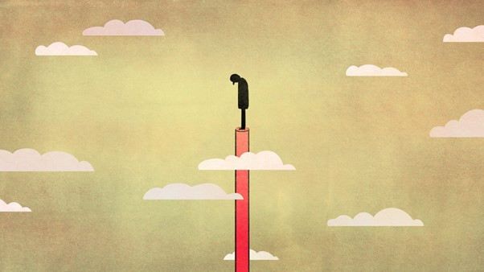

Crisis Files – 1
In the lead up to finally getting back to delivering courses again and working directly with teachers, students and most importantly parents I have been working on new material with respect to PCSD (Post-Covid Stress Disorder) and the exacerbating effects of social media.

To me this feels like the defining issue of this present generation.

Outrage Culture:

Two key principles of social media that all young people need to be aware of are:
- everything they post is 'findable' forever, even if they delete it, and
- if the service is free then they are the product – all their data is being sold.
And the most important thing that teachers and parents need to help young people understand is the nature of the unequal battle being played out across the screen of their phone, tablet or laptop.
They are on one side and on the other side is a billion dollar AI with one aim, to keep their attention on the screen.
That AI is constantly working to harvest their attention because more attention equates to more $ earned by the platform from their advertisers. This is the business model of Facebook, Instagram, YouTube, TikTok, Twitter, Snapchat, LinkedIn, Amazon, Netflix, Google etc. etc.
So each AI is competing to put in front of their users things that will keep their attention and keep them scrolling. Outrage is always no1 for clicks, followed by anger, horror and disgust.
Social media AI operate by gathering data on all users in order to craft the feed for each user and immerse them in a feed environment unique to them designed to maximise their engagement – in terms of time on line. The end result of this process is to immerse every person in a echo chamber of their own making which reinforces all that they believe no matter how crazy and convinces them that they are engaged with the truth.
Ideological capture by fringe 'crazies' like QAnon can be one result but more pernicious is the immersing of all our young people in feeds promoting outrage, anger, horror and disgust which only serves to increase their cynicism and vulnerability and work against the resilience they need to cope in a post-pandemic world.
What is the solution?
Realistically, I can see that asking young people to disengage completely with social media to avoid the negative effects on mental health is not an idea that is going anywhere, so the only influence anyone can exert is to exert careful control over all connections, all clicks, all links and all likes in an effort to create a profile for the AI to feed on which only reinforces positive memes.
Plus, install Adblock Plus www.adblockplus.org to eliminate all advertising where possible.
But most importantly, all children at school need to learn social media skills as a vital part of their process skills training.

A full suite of Social Media skills training exercises for students are available at lalatat.com

