The Defining Existential Crisis of the Present Generation:

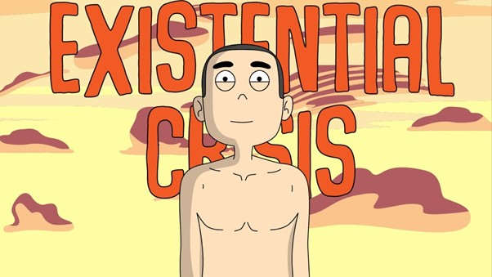

Crisis Files – 2

Social Media ATL Skills
What are the most important social media skills for school children to learn – preferably before they engage with social media?

For me the most important thing for them to realise is that social media is not reality, it is a construct generated by a super-computer with only one purpose - to keep eyeballs on screen, to keep you scrolling.
The existential problem of social media is that young people especially come to believe that the reality of their lives – friends, connections, news, truth, entertainment, engagement, learning – only happens through social media.
I believe our collective responsibility as teachers and parents is to demonstrate unequivocally to young people that reality is what happens when they turn their phones off.
As Albert Mehrabian (University of California, Los Angeles ) showed many years ago in his 1971 book Silent Messages - 7 percent of meaning is communicated through spoken word, 38 percent through tone of voice, and 55 percent through body language.
Reality is found in the personal eyeball-to-eyeball contact with other human beings, when real communication both verbal and non-verbal can occur.

And yet how many people ever turn their phones off?

Tasks for students:
- Identify their own virtues and values, who they are as a person off-line and who they want to be.
First students need to identify what virtues in themselves and others they value most highly – have them put words like these in a priority order and work out what their top 5 virtues are:
Benevolence, generosity, honesty, faithfulness, integrity, good manners, politeness, wisdom, compassion, patience, humility, determination, forgiveness, courage, tolerance, kindness, kind treatment of animals, hope, charity, fulfilment of promise

- Identify the difference between reputation and character, their real vs online persona.
Use the John Wooden quote – “Be more concerned with your character than your reputation, because your character is what you really are, while your reputation is merely what others think you are” as a starter for a discussion about which is more important and which is most effected by social media.
Once they are clear about the virtues they value most they can then start to think about how they can demonstrate those virtues both in their daily life and online on social media.

- Create an online identity focused on strengths, goals and exemplifying their virtues
Then the task for students is to carefully craft their online persona to focus on their strengths rather than their weaknesses, their hopes rather than their fears, their goals and plans to achieve them and exemplifying all the virtues they value the most.

- Find positive, inspirational adults to follow
Only link to and follow people who inspire you, who exemplify the virtues you value the most, who help you to be more of the person you want to be, who help you to achieve your goals and lead a most purpose driven and principle based life.

- Make ethical choices about ‘likes’
Only ever like posts that are helping you to be the person you most want to be. Remember that the only way to make the social media AI work for you is to make sure that all your connections, all clicks, all links and all likes create a profile for the AI to feed on which only reinforces positive memes.
- Set up and maintain strong relationships that exist both on and off line
And make sure you are spending at least as much time each day interacting with people face-to-face as you are spending communicating online on social media.

- Have regular, deliberate, digital holidays – no screen time at all for a set period of time.

How long could you last with no screen time at all?
How about just without a phone? How many people could manage a day without their phone? The funny thing is everyone thinks that would not be a problem but how many people actually do it? Ever?

All these exercises and many more are available in LALATAT.

Go to lalatat.com

