ATL SKILLS FOR OUR POST-COVID, AI-ENHANCED, DIGITAL WORLD

Lance G. King

Daegu IB World School Conference
December 7, 2024

lance@taolearn.com
www.taolearn.com
Lance King
DAY 1 – Designing, planning, implementation

Positives of the pandemic:
- 20% of students improved their academic performance
- All were great self-managed learners – with all the skills for success in the post-Covid digital world

By 2030:
- Automated cars, buses, taxis, trains, aircraft, food delivery, doctor’s visits, banking, law, most retail
- Artificial Intelligence involved in all aspects of life
- Most employees will be freelance – contracted into on-line collaborative teams working on specific projects
- Selection for employment in work teams will be based on skills and experience and driven by Social Media
- Social Media identity will be as important as real-life identity
- Highest paid skills will be research, analysis, finding the truth, predicting trends, adapting, creating and problem solving

“The world economy no longer rewards people just for what they know, the world economy rewards people for what they can do with what they know” - Andreas Schleicher, PISA, OECD

In order to cement in the gains and lessons of the Covid years:
- Teachers need to be very familiar with every website that teaches their subject material – both the free and the paid sites and schools need to invest in subscriptions for teachers in all the best sites
- Teachers need comprehensive training in how to design engaging, independent learning lessons for their students that utilise the best on-line resources available remotely
- Students need to be taught all the ATL skills they need for effective self-managed learning
- Students need training in and regular practice of the management of their own learning
- Becoming an effective, successful self-managed learner needs to be made into a high status achievement at school, something all children will aspire to.

14 Category ATL Skills model – for PYP, MYP, CP & DP:
Communication
1. Language Skills
2. Media Skills
Social
3. Group Skills
4. Social Skills
Self-Management
5. Metacognitive Skills
6. Organization Skills
7. Study Skills
8. Character Skills
Research
9. Research Skills
10. Decision Making Skills
Thinking
11. Critical Thinking Skills
12. Computational Thinking Skills
13. Idea Generation Skills
14. Adaptive Thinking Skills

For more detail go to www.taolearn.com/wp-content/uploads/2024/01/2414CatATLFulllFramework.xlsx

Harmonising the 14 Category model with the 2022 Revised Korean National Curriculum Competencies:

2022 Korea National Competencies | 14 Category 21st C Skills
Self-management | 1. Metacognitive Skills  2. Organization skills
Knowledge information processing | 3. Study Skills  4. Research Skills  5. Decision Making Skills  6. Critical Thinking Skills  7. Computational Thinking Skills
Creative thinking | 8. Idea Generation Skills  9. Adaptive Thinking Skills
Aesthetic emotional | 10. Character Skills
Collaborative communication | 11. Language skills  12. Media skills
Civic | 13. Group skills  14. Social skills

Purpose of any ATL skills programme:
- To develop self-managed learners:
  - by teaching all students a full curriculum of ATL skills
  - by having students use their ATL skills to improve their academic performance in all their school subjects
  - by giving students increasing practice in the management of their own learning from Gd 1-12
- To help students realise that they do have control over their own success at school and beyond

Any ATL skills programme is all about focusing students on factors to improve their success that are in their control.
- Metacognitive ATL skills for self-awareness - - thinking about own thinking and learning eg: noticing and changing learning strategies, continuously improving learning effectiveness
- Cognitive ATL skills for academic success - - active information processing and retrieval strategies eg: note-making, listening, time management, questioning, researching
- Affective ATL skills for mental health - enabling the student to gain some control over mood, motivation and attitude eg: self-motivation, perseverance, resilience, emotional management

Three key phases of ATL skill proficiency development:
- Competence - student copies skill and learns ‘how best’ to use the skill with simple content
- Practice - student then practices using the skill with subject content of increasing complexity and works towards being able to use the skill whenever needed
- Mastery - student can use the skill independently of the teacher and the classroom

Task 2: Mapping learning challenges
- Get into grade level groups
- Each group - discuss what are the most important learning-process challenges for students in your year – consider both transition and assessment challenges
- Put all the learning challenges into a priority order
- Decide on your top five
- Write your Grade level at the top of one A1 page, then list your top five learning challenges on your page and pin it on the wall – in sequence

Task 3: Mapping ATL skills to meet learning challenges
- Get out of grade level groups, get into pairs with a friend, take a learning walk, read what is on each page.
- Pick a grade level you are both familiar with, pick one learning challenge, discuss what the specific ATL skill(s) would be that would help a student to overcome that challenge – what do they need to know how to do?
- Think about when a student would need to learn that particular ATL skill in order to be ready to use it when needed
- Write the ATL skill strand on a Post-it note and stick it on the appropriate grade page – when it needs to be learned.
- Repeat
- Be very precise about exactly what skills are needed – exactly what does a student need to know how to do to succeed in each learning challenge?

Task 4: Mapping ATL skills to meet learning challenges
- Get back into your grade level groups, take your page off the wall
- Analyse all the Post-it notes on your page, eliminate duplication
- Decide on the Top Ten ATL skills for your grade
- Write them on the page, put the page back on the wall
- Look across grades for duplication, leave the earliest mention cross out the subsequent ones
- Now you have the beginnings of a plan, next step is to decide:
  - Who, when, where & how?

Two steps to teaching ATL skills:
- Explicit Teaching:
- Designing parts of lessons or whole lessons or homework exercises to explicitly teach an ATL skill strand
- Developing ATL skill strand Competence using simple content
- Followed by - Implicit Teaching:
  - Having students Practice their ATL skills in inquiry-based subject lessons
  - Developing and improving ATL skill competence up to Mastery level by using them with subject content in subject lessons

Where will the time come from?
Developing student Competence in the ATL skills they need takes teaching time – where will this time come from?
- Within the existing timetable?
  - taking time out of existing lessons?
  - taking home-room time?
- Outside the existing timetable?
  - as homework exercises
  - in an after-school ‘learning skills’ class?
- This is the most important question.

Part 1 – Explicit teaching of ATL skills:
- What if – every MYP and DP student had a one-hour/week ‘Learning Skills’ lesson in their timetable?
  - The Learning Skills program could be aligned with student development so all students develop Competence in all the cognitive, metacognitive, social and emotional ATL skills they need when they need them
  - The purpose of the Learning Skills lessons would be for students to learn ‘how best’ to use each ATL skill
  - Each student learns the ATL skills they need at the time, to cope with the learning, social and emotional challenges they face

Part 2 – Implicit teaching of ATL skills:
- Then students can practice and improve their ATL skills in normal subject lessons.
- Teachers can feel confident that students will already have some competence in all the ATL skills they need to cope with the learning challenges in the classroom
- Teachers will feel encouraged to use more inquiry-based teaching, problem-based teaching, experiential learning, independent and remote learning
- Students will use their ATL skills to learn all their subjects more effectively and more efficiently
- Students will master all the ATL skills they need for their future education, job, career and business success

Task 5: Mapping the development of skill Competence
- Stay in your grade level groups, work in pairs, divide up your Top Ten ATL skills between the group
- Each pair do your research, find out how other people practice, coach or ‘teach’ your particular ATL skill strand
- Design one generic exercise any teacher could use to introduce the skill to the students for the first time using any content to develop Competence
- Then design one exercise you could use to have students Practice this skill in one of your subject classes
- Write the skill and both exercises into your grade level spreadsheet

To develop self-managed learners:
- Teachers must learn how to limit ‘teaching’ and allow self-managed learning to take place
- Only by being allowed to practice the skills of self-managed learning will students become effective self-managed learners

Task 6: How to verify the ‘truth’?
- Work as a grade level group
- Create an age appropriate exercise for your students to do to teach them how to verify the truth of their research
  - What needs to be checked?
  - How do they check?
  - Are there any rules for every search?
    - If so what are they?

Check out the Mulgrave School – Teaching ATL Skills - www.youtube.com/watch?v=MVOAuxIdVnE&list=PLhEWC1-9VPlYx00lJnJHjAVH8R1Fz83rP

OPCVL – Origin, Purpose, Content, Value, Limitations

CRAAP – Currency, Relevancy, Authority, Accuracy, Purpose

Truth and ai – key ATL skill set:
- Understanding the limits of large language-based models – predictive text only
- Finding credible, well referenced ai – Perplexity.ai
- Asking good research questions – drilling down, questions within questions
- Verifying the truth – going to primary sources
- Being wary of hallucinations
- Constructing evidence-based arguments
- Re-writing, finding your own flow/style

Metacognitive skills – reflection, thinking about thinking, learning about learning
- Metacognitive Knowledge – students noticing and learning how they are learning - the thinking and learning strategies, techniques and skills they use to achieve successful learning
- Metacognitive Performance – students using that knowledge to improve their learning performance, change ineffective strategies, try new techniques, learn new skills
  - The key to metacognition is noticing your own thinking

Task 7: Developing Metacognitive Knowledge using Think-Alouds:
- The ‘Student’ – is working on the puzzle and is allowing all their internal dialogue to be audible, they are saying out loud every word and every thought that is coming into their mind
- The ‘Teacher’ - is not working on the puzzle, just listening carefully to the ‘student’ and encouraging them to keep continuously talking - by saying things like “keep talking, keep talking…” and by asking questions:
  - questions which ask the student what they are thinking, what are the difficulties they are having with the puzzle and how they are going to overcome them
  - questions which focus on the thinking process NOT on the solution to the puzzle
  - THE ‘TEACHER’ MUST NOT HELP THE ‘STUDENT’ FIND THE ANSWER

Task 8: Developing metacognitive knowledge through reflection on process
- In those exercises, when you got ‘stuck’ -
  - what did you say to yourself?
  - What did you imagine?
  - describe what you did to move past a ‘stuck’ moment
- That is your problem-solving process for visual puzzles
- Teach it to your students

The Metacognitive Cycle:
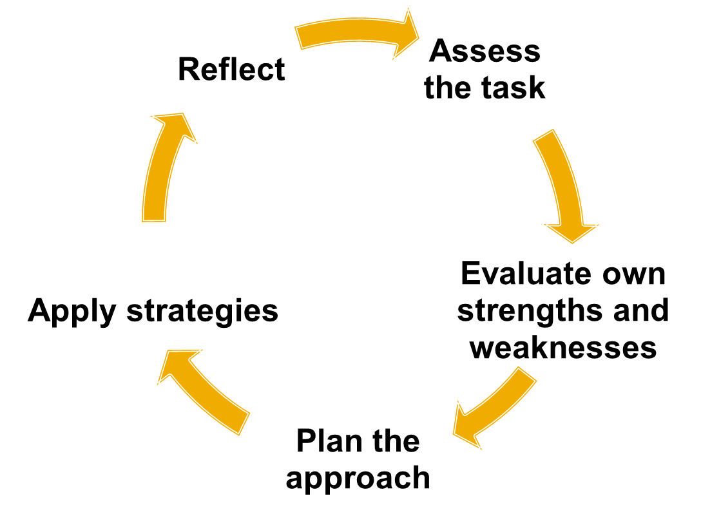
Developing students’ reflection on process using puzzles and problems:
- Give your students puzzles to solve and ask them to notice their own problem-solving strategies
- Ask students who successfully solve problems to outline their thinking process – the questions they asked themselves, the logic they followed – share with all students, create a thinking strategies noticeboard
- See how many different thinking strategies your students can come up with
- Get them to try deliberately using a new strategy for a different puzzle

Using assessment of understanding to develop metacognitive skills:
- At the end of any unit of work
  - Have they achieved the content and process goals?
  - What is their evidence?
    - Is this really what you as a teacher need to know?
  - What don’t they understand yet?
  - What questions do they have?
- This turns assessment into metacognitive training – recognising gaps in knowledge and understanding.
- Teaching students how to notice what they don’t yet know is far more useful than having them prove what they do know
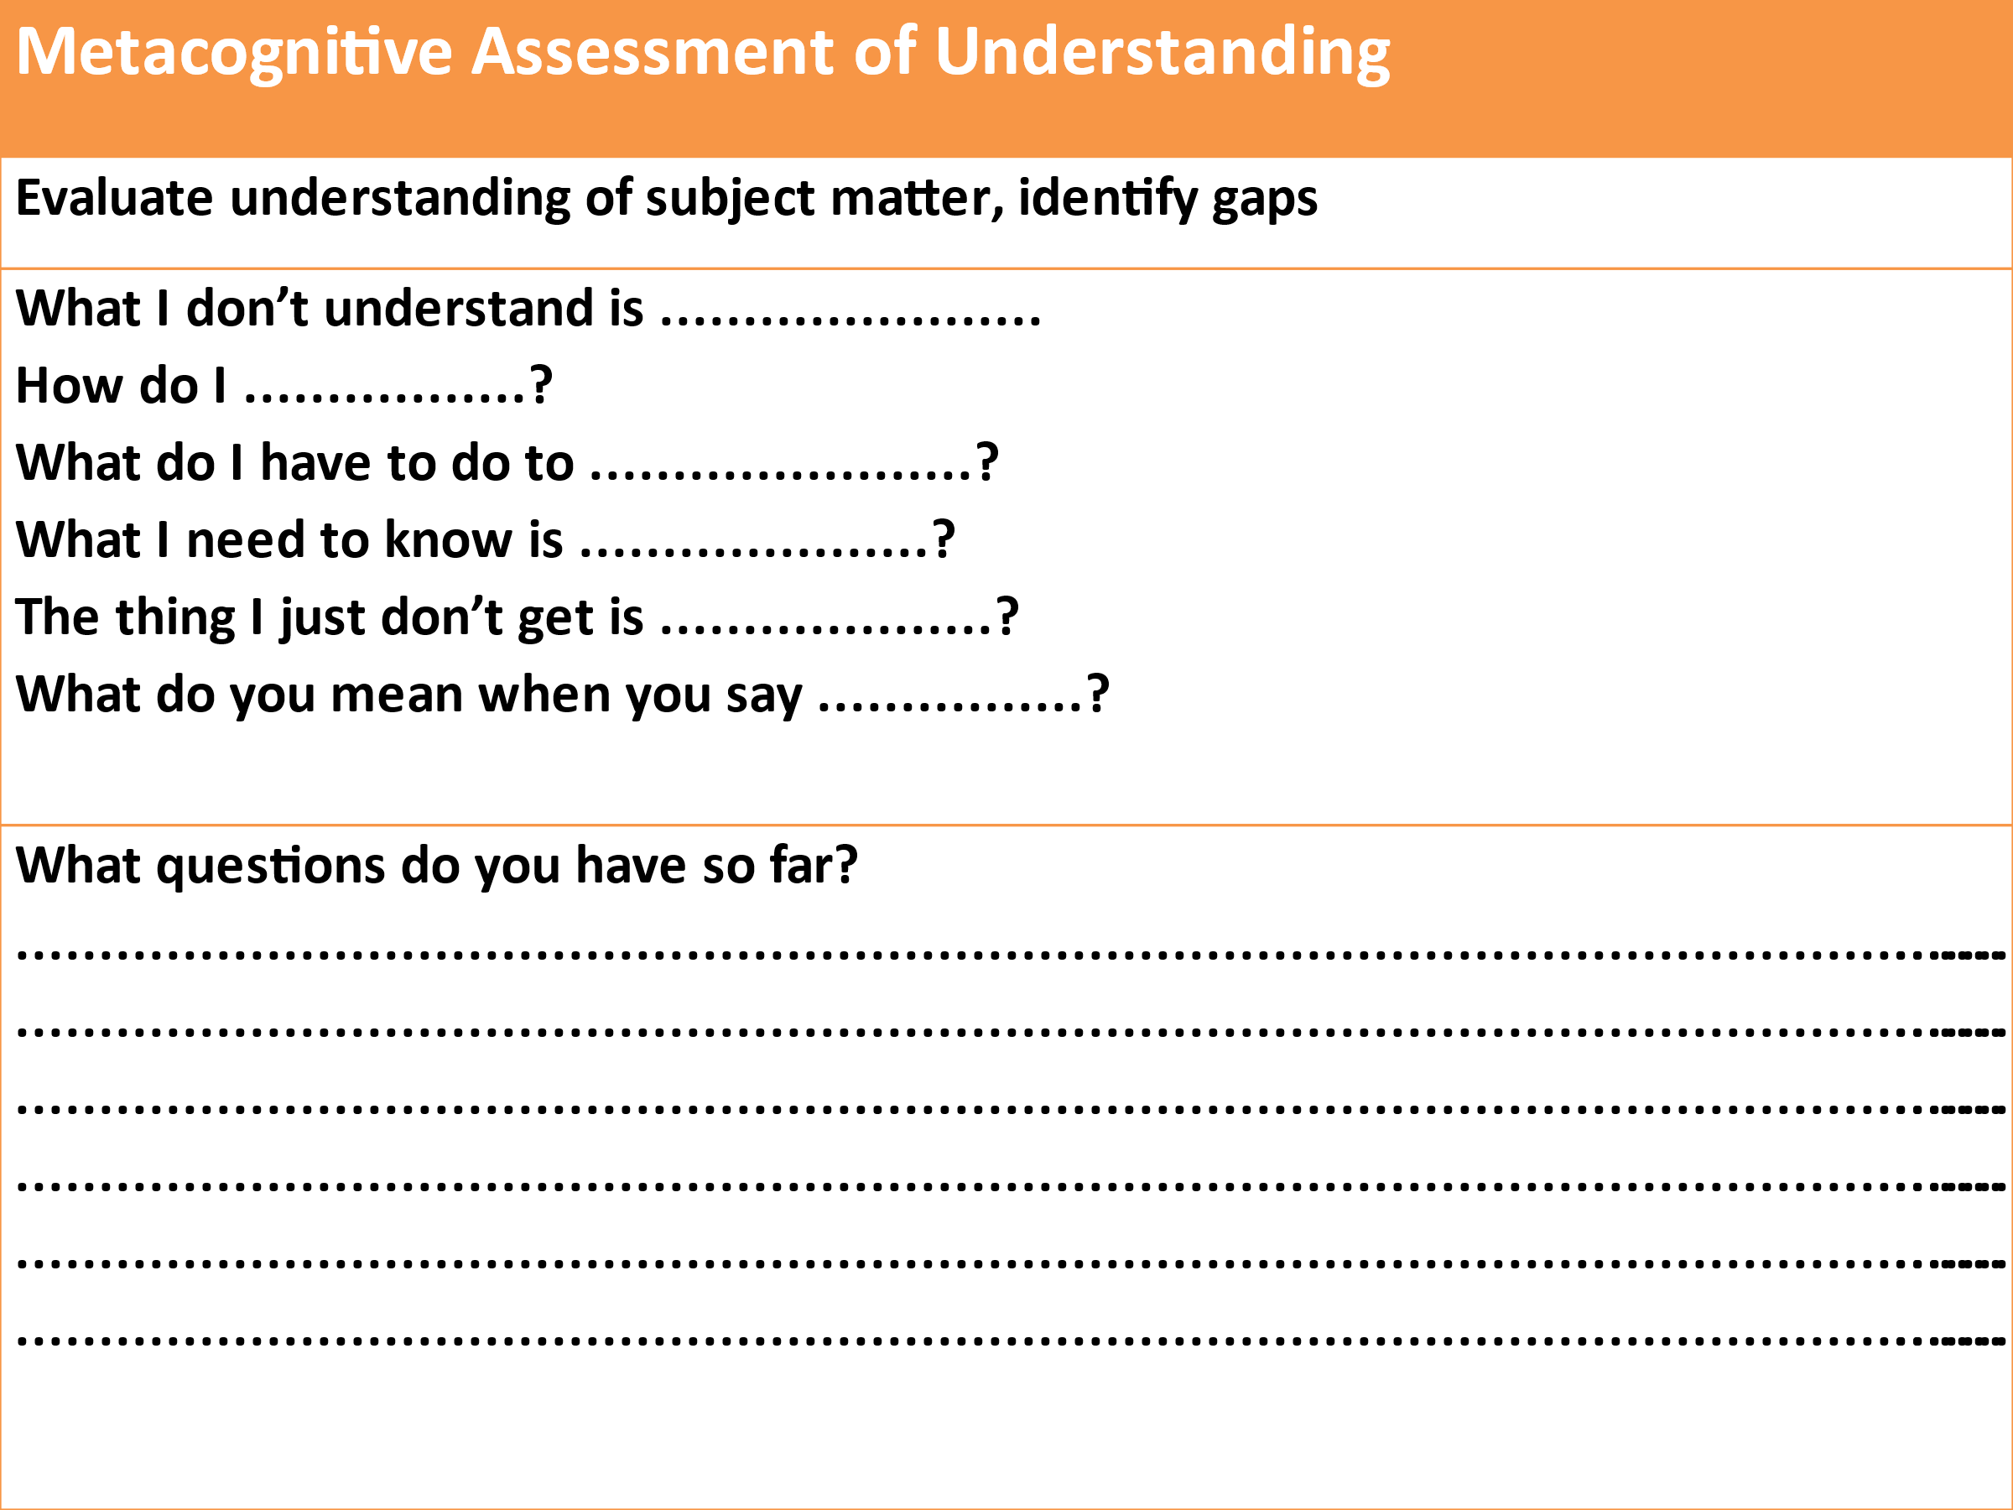

Assessing ATL skills:
- When your ATL programme is working well you will see:
  - improvements in the efficiency and effectiveness of your students learning in all their normal subjects
  - improvements in their performance in formative and summative assessments and all high-stakes exams, and
  - improvements in in their ability to manage their own learning

Using ATL skills self-assessment to develop metacognition:
- Learning how to accurately self-assess your own work is a ATL skill in itself
  - get students to self-assess their own ATL skill development
    - for this you first need Mastery statements for all ATL skills
    - then you need one development rubric to cover all ATL skills

9: ATL skill Mastery
- In your grade level groups add a Mastery column to each spreadsheet
- ‘Mastery’ is the highest standard of independent use of that skill that you would expect to see at school – by the end of your program, with no teacher support:
  - “By the time our students finish the (PYP, MYP, DP) they will be able to ………………………...”
- Take your particular ATL skill from the previous mapping exercise and create a mastery statement for that skill
- Add your mastery statement to the spreadsheet

Rubric for all ATL skill development and assessment:
Competence |  |  | Practice |  |  |  | Mastery
Watching | Copying | Starting |  | Practising | Getting better | Got it! | Teaching
I know what the use of the skill looks like when others are using it | I can copy someone else using the skill | I am starting to use the skill by myself |  | I am using the skill by myself in familiar situations | I am getting better at using the skill in unfamiliar situations | I am able to use the learning skill whenever I need to | I use the skill without needing to think it through first
I can break the skill down into steps | I use the skill one step at a time | I am still conscious of using the skill one step at a time |  | I am starting to put all the steps of the skill together | I can usually use the skill without referring to the way that I have done it in the past. | I can confidently use the skill without referring to the way that I have done it before | I am capable of teaching other students how to use the skill
When I try to use the skill myself I make lots of mistakes and ask lots of questions | I still make mistakes and ask for help but I am getting better at correcting my own mistakes | I can correct my mistakes with some help |  | I can correct my own mistakes | Any mistakes I make I can quickly correct | I can usually correct any mistakes automatically | I correct any mistakes I make automatically
I need lots of help to use the skill | I can use the skill in familiar situations with some help | I still need help to use the skill sometimes |  | I don’t need help to use the skill in familiar situations anymore | I still need help to use the skill in unfamiliar situations sometimes | I hardly ever need help to use the skill anymore | I can use the skill in unfamiliar situations without any help from anyone else

Student self-assessment of ATL skill development:
Student Self-Assessment of ATL Skill Proficiency
ATL Skill | Competence |  | Practice |  |  |  | Mastery
 | Watching | Copying | Starting | Practising | Getting better | Got it! | Teaching

Developing self-assessment as an ATL skill in itself:
- Use self-assessment to teach students how to accurately judge the quality of their own output - the most important ATL skill for all future education and careers
- When assessing students’ subject work try:
  - asking them to include a self-assessment on what they did well and what they could improve on
  - give them feedback on both their subject work and the quality of their self-assessment

Three valid forms of ATL skills assessment:
- Student self-assessment of ATL skills proficiency completed pre~ and regularly post~ training
- Teacher reporting on ATL skills in reports – qualitative not quantitative
- Designing subject-based assessments so that generating the answers needed requires the use of specific ATL skills at the appropriate level of proficiency

Please fill out the Evaluation Form before you leave.

Email me with any questions or comments: lance@taolearn.com

Thank you for your participation.
Lance King

