THINKING AND LEARNING SKILLS FOR OUR POST-COVID,
AI-ENHANCED,
DIGITAL WORLD:

Lance G. King

lance@taolearn.com
www.taolearn.com
Lance King

21st C SKILLS FOR OUR POST-COVID, AI-ENHANCED, DIGITAL WORLD
DAY 1
Positives of the pandemic:
- 20% of students improved their academic performance
  - All were great self-managed learners – with all the skills necessary for success in the post-Covid, digital world

By 2030:
- Automated cars, buses, taxis, trains, aircraft, food delivery, doctor’s visits, banking, law, most retail
- Artificial Intelligence involved in all aspects of life
- Most employment will be freelance – on-line collaborative teams working on specific projects
- Selection for employment in work teams will be based on skills and experience and driven by Social Media
- Social Media identity will be as important as real-life identity
- Highest paid skills will be research, analysis, finding the truth, predicting trends, adapting, creating and problem solving

“The world economy no longer rewards people just for what they know, the world economy rewards people for what they can do with what they know” - Andreas Schleicher, PISA, OECD

Purpose of any 21st C skills programme:
- To develop self-managed learners:
  - by teaching all students a full curriculum of 21st C skills
  - by having students use their 21st C skills to improve their academic performance in all their school subjects
  - by giving students increasing practice in the management of their own learning from Gd 1-12
- To help students realise that they do have control over their own success at school and beyond

Any 21st C skills programme is all about focusing students on factors to improve their success that are in their control.

Three key phases of 21st C skill proficiency development:
- Competence - student copies skill and learns ‘how best’ to use the skill with simple content
- Practice - Student then practices using the skill with subject content of increasing complexity and works towards being able to use the skill whenever needed
- Mastery - Student can use the skill independently of the teacher and the classroom

Metacognitive 21st C skills for self-awareness
Cognitive 21st C skills for academic success
Affective 21st C skills for mental health

Task 4: Mapping learning challenges
- Get into Grade level groups
- Each group - discuss what are the most significant academic, social and emotional challenges for students in your grade
- Prioritise based on the effect on student learning
- Decide on your top 5-10
- Write your grade level at the top of one A1 page, then list your top learning challenges and pin it on the wall – in sequence

Task 5: Mapping 21st C skills to match learning challenges
- In pairs, pick one learning challenge, discuss what the specific 21st C skill(s) would be that would help a student to overcome that challenge – what do they need to learn how to do?
- Think about when a student would need to learn that particular 21st C skill in order to be ready to use it when needed
- Write the 21st C skill strand on a Post-it note and stick it on the appropriate grade page – when it needs to be learned.
- Repeat
- Be very precise about exactly what skills are needed – exactly what does a student need to learn how to do to succeed in each learning challenge?

Task 6: Top 10 21st C Skills for your Grade level:
- Take your Grade level page off the wall
- Analyse all the Post-it notes on your page, eliminate duplication
- Decide on the Top Ten 21st C skill strands for your year
- Write them on a new page, put the page back on the wall
- Now you have the beginnings of a plan, next step is to decide:
  - Who, when, where & how?

Two steps to teaching 21st C skills:
- Explicit Teaching:
- Designing parts of lessons or whole lessons or homework exercises to specifically teach an 21st C skill strand
- Developing 21st C skill strand Competence using simple content
- Implicit Teaching:
  - Having students Practice their 21st C skills in inquiry-based subject lessons
  - Developing and improving 21st C skill competence up to Mastery level by using them with subject content in subject lessons

Where will the time come from?
- Developing student Competence in the 21st C skills they need takes teaching time – where will this come from?
  - Within the existing timetable?
    - Taking time out of existing lessons?
    - Taking home-room time?
  - Outside the existing timetable?
    - As homework exercises
    - In an after-school ‘learning skills’ class?

Part 1 – Explicit teaching of 21st C skills:
- What if – every student had a one-hour/week ‘21st C Skills’ lesson in their timetable?
  - The 21st C Skills program could be aligned with student development so all students develop Competence in all the cognitive, metacognitive, social and emotional 21st C skills they need when they need them
  - The purpose of the 21st C Skills lessons would be for students to learn ‘how best’ to use each 21st C skill
  - Each student would learn the 21st C skills they need, when they need them, to cope with the learning, social and emotional challenges they face

Part 2 – Implicit teaching of 21st C skills:
- Then students can practice and improve their 21st C skills in normal subject lessons.
- Teachers can feel confident that students will already have some competence in all the 21st C skills they need to cope with the learning challenges in the classroom
- Teachers will feel encouraged to use more inquiry-based teaching, problem-based teaching, experiential learning, independent and remote learning
- Students will use their 21st C skills to learn all their subjects more effectively and more efficiently
- Students will master all the 21st C skills they need for their future education, job, career and business success

Who knows best what the learning challenges facing students are?
- Try asking each new year group:
  - “Last year, what did you have to learn how to do, to cope with all the learning expected of you?”
- and then pass that information on to the previous year’s teachers.
- That can be the foundation of your explicit 21st C skills teaching program.
- Or the content of a volunteer, students “learning skills” after school club (ongoing CAS project?)

Task 7: Mapping the development of skill Competence
- Stay in your year level groups, work in pairs, divide up your Top Ten 21st C skills between the group
- Each pair do your research, find out how other people practice, coach or ‘teach’ your particular 21st C skill strand
- Design one age appropriate exercise any teacher could use to introduce the skill to the students for the first time using any content to develop Competence
- Then design one exercise you could use to have students Practice this skill in one of your own subject classes
- Write the skill and both exercises into your grade level spreadsheet

My Korean language ATL Skills Workbooks for MYP and DP students are available as follows:
- MYP Approaches to Learning: Student Workbook
https://www.hakjisa.co.kr/subpage.html?page=book_book_info&bidx=6421
- DP Approaches to Learning: Student Workbook
https://www.hakjisa.co.kr/subpage.html?page=book_book_info&bidx=6422
See Professor Ko’s ATL exercises at https://teachercanvassador.my.canva.site/tribes-21st Cs
Also find Lenny Dutton’s resources at www.excitededucator.com/home/21st C-toolkit

My Korean language 21st C Skills Student Workbooks for Middle and High School students plus my teachers guide called Teaching 21st C Skills in Korea will be published by March 2026 by Hakjisa Publishers.

To develop self-managed learners:
- Teachers must learn how to limit ‘teaching’ and allow self-managed learning to take place
- Only by being allowed to practice the skills of self-managed learning will students become effective self-managed learners

3 things I know to be true are:
1.
2.
3.

Task 8: How to verify the truth?
- Work in pairs or small groups
- Create an age appropriate exercise for your students to do to teach them how to verify the truth of any research
  - What needs to be checked?
  - How do they check?
  - Are there any rules for every search?
    - If so what are they?

Check out Mulgrave School – Teaching ATL Skills https://www.youtube.com/playlist?list=PLhEWC1-9VPlYx00lJnJHjAVH8R1Fz83rP

Truth and AI – key 21st C skill set:
- Understanding the limits of large language-based models – predictive text only
- Finding credible, well referenced ai – Perplexity.ai
- Asking good research questions – drilling down, questions within questions
- Verifying the truth – going to primary sources
- Being wary of hallucinations – triple fact checking
- Constructing evidence-based arguments
- Re-writing, finding your own flow/style

Metacognitive skills – reflection, thinking about thinking, learning about learning
- Metacognitive Knowledge – students noticing and learning how they are learning - the thinking and learning strategies, techniques and skills they use to achieve successful learning
- Metacognitive Performance – students using that knowledge to improve their learning performance, change ineffective strategies, try new techniques, learn new skills
  - The key to metacognition is noticing your own thinking

Task 9: Developing Metacognitive Knowledge using Think-Alouds:
- The ‘Student’ – is working on the puzzle and is allowing all their internal dialogue to be audible, they are saying out loud every word and every thought that is coming into their mind
- The ‘Teacher’ - is not working on the puzzle, just listening carefully to the ‘student’ and encouraging them to keep continuously talking - by saying things like “keep talking, keep talking…” and by asking questions:
  - questions which ask the student what they are thinking, what are the difficulties they are having with the puzzle and how they are going to overcome them
  - questions which focus on the thinking process NOT on the solution to the puzzle
  - THE ‘TEACHER’ MUST NOT HELP THE ‘STUDENT’ FIND THE ANSWER

Task 10: Developing metacognitive knowledge through reflection on process
- In those exercises, when you got ‘stuck’ -
  - what did you say to yourself?
  - what did you imagine?
  - describe what you did to move past a ‘stuck’ moment
- That is your problem-solving process for visual puzzles
- Explain it to your students
- How aware of their own thinking are your students?
  - how metacognitive?

The metacognitve learning cycle:

Developing student’s reflection on the learning process using puzzles.
- Give your students puzzles and problems to solve and ask them to notice their own problem-solving strategies
- Ask students who successfully solve problems to outline their thinking process – the questions they asked themselves, the logic they followed – share with all students, create a thinking strategies noticeboard
- See how many different thinking strategies your students can come up with
- Get them to try deliberately using a new strategy for a different puzzle

Using subject assessment to develop metacognition:
- At the end of any unit of work
  - Have they achieved the content and process goals?
  - What is their evidence?
    - Is this really what you as a teacher need to know?
  - What don’t they understand yet?
  - What questions do they have?
- This turns assessment into metacognition training – recognising gaps in knowledge and understanding.
- Teaching students how to notice what they don’t yet know is far more useful than having them prove what they do know:

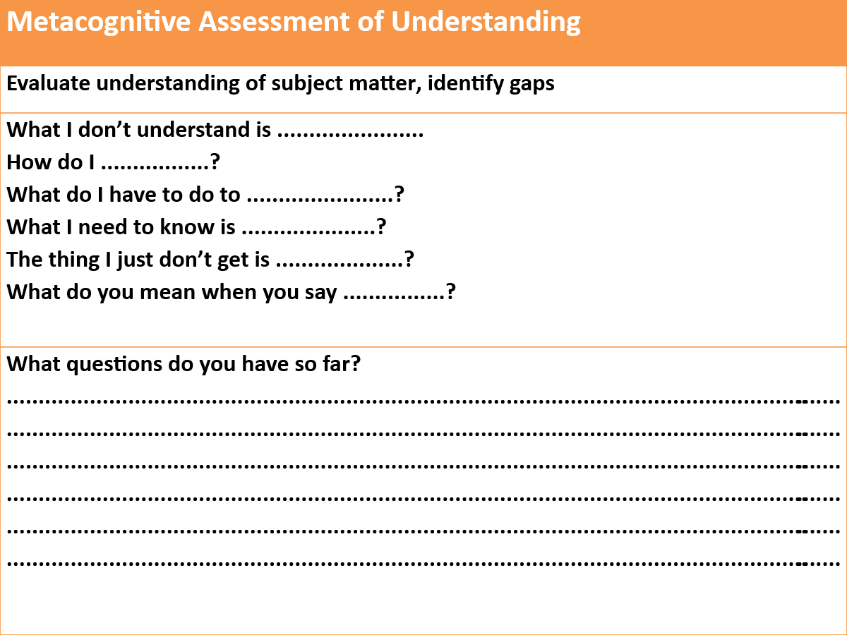
Assessing 21st C skills:
- When your 21st C programme is working well you will see:
  - improvements in the efficiency and effectiveness of your students learning in all their normal subjects
  - improvements in their performance in formative and summative assessments and all high-stakes exams, and
  - improvements in in their ability to manage their own learning

Using 21st C skills self-assessment to develop metacognition:
- Learning how to accurately self-assess your own work is an 21st C skill in itself
  - get students to self-assess their own 21st C skill development
    - for this you first need Mastery statements for all 21st C skills
    - then you need one development rubric to cover all 21st C skills

Task 11: 21st C skill Mastery
- In your year groups, have someone add a Mastery column to each spreadsheet
- ‘Mastery’ is the highest standard of independent use of that skill (with no teacher help) that you would expect to see at school – by the end of your program:
“By the time our students finish …………………………………………… they will be able to ………………………………………………………...”
- Take your particular 21st C skill strand from the previous mapping exercise and create a mastery statement for that skill
- Add your mastery statement to the spreadsheet

Rubric for all 21st C skill development and assessment:
Competence |  |  | Practice |  |  |  | Mastery
Watching | Copying | Starting |  | Practising | Getting better | Got it! | Teaching
I know what the use of the skill looks like when others are using it | I can copy someone else using the skill | I am starting to use the skill by myself |  | I am using the skill by myself in familiar situations | I am getting better at using the skill in unfamiliar situations | I am able to use the learning skill whenever I need to | I use the skill without needing to think it through first
I can break the skill down into steps | I use the skill one step at a time | I am still conscious of using the skill one step at a time |  | I am starting to put all the steps of the skill together | I can usually use the skill without referring to the way that I have done it in the past. | I can confidently use the skill without referring to the way that I have done it before | I am capable of teaching other students how to use the skill
When I try to use the skill myself I make lots of mistakes and ask lots of questions | I still make mistakes and ask for help but I am getting better at correcting my own mistakes | I can correct my mistakes with some help |  | I can correct my own mistakes | Any mistakes I make I can quickly correct | I can usually correct any mistakes automatically | I correct any mistakes I make automatically
I need lots of help to use the skill | I can use the skill in familiar situations with some help | I still need help to use the skill sometimes |  | I don’t need help to use the skill in familiar situations anymore | I still need help to use the skill in unfamiliar situations sometimes | I hardly ever need help to use the skill anymore | I can use the skill in unfamiliar situations without any help from anyone else

Student self-assessment of 21st C skill development:
Student Self-Assessment of 21st C Skill Proficiency
21st C Skill | Competence |  | Practice |  |  |  | Mastery
 | Watching | Copying | Starting | Practising | Getting better | Got it! | Teaching

Developing self-assessment as an 21st C skill in itself:
- Use self-assessment to teach students how to accurately judge the quality of their own output - the most important 21st C skill for all future education and careers
- When assessing students’ subject work try:
  - asking them to include a self-assessment on what they did well and what they could improve on
  - give them feedback on both their subject work and the quality of their self-assessment

Three valid forms of 21st C skills assessment:
- Student self-assessment of 21st C skills proficiency completed pre~ and regularly post~ training
- Teachers reporting on 21st C skills in reports – qualitative not quantitative
- Designing subject-based assessments so that generating the answers needed requires the use of specific 21st C skills at the appropriate level of proficiency

DAY 2

Teaching Cognitive 21st C skills for academic success and Affective 21st C skills for mental health

Declining future population predictions for South Korea:
Fewer children in school means more resources for each one:
- Smaller class sizes
- More individual attention from teachers
- Better access to technology and extracurricular activities
- With AI technologies being integrated, children will benefit from highly personalised and adaptive teaching tailored to each individual’s learning abilities and disabilities.
- More places available in universities
- More jobs available
- Increased individual tax burden
- Increased financial burden on each child for support of own extended family
- Increased urgency for today’s children to succeed in school
- Increased need to pursue high paying careers over life enjoyment
To future-proof your students, schools in South Korea will need to:
- Teach every child a full curriculum of mental health skills focused on developing emotional intelligence, resilience, self-care and self-motivation
- Encourage collaboration over competition in learning environments, measure students progress against themselves, develop self-assessment
- Use AI systems to help identify students showing signs of mental health issues early on and alert teachers or counsellors for support.
- Provide comprehensive mental health services within schools to ensure early intervention for students facing any mental health problems.

Start with teaching Resilience:
Help students notice their own physical resilience:
    - When they bounce back from adversity
    - Everyone does it sometimes:
      - PE, sports and other physical activities
      - Learning to cope with a new culture, school, country, language
    - Help them to notice resilience – in themselves and in others

Task 1: Success and Failure:
 | What happened? | What do you think was the cause of your success or failure? | What did you do next?
A time when you set a goal and achieved it was …
A time when you set a goal and didn’t achieve it was…

"All the top academic students had learned how to fail well
whereas all the lowest academic students were failing badly"

Reactions to failure
Failing Well | Failing Badly
- Acknowledge your failure,  - take responsibility for all the factors that were in your control  - work out what you could have done better  - make changes, and  - do it again, and again if necessary  - but do it differently, every time | - Blame the school or the ‘system’  - Blame other people  - Pretend there is no failure  - Add ‘drama’ to failure to avoid dealing with it  - Avoid any activity that could possibly lead to failure
Full article available at www.taolearn.com/wp-content/uploads/articles/article88.pdf

On receiving poor results - notice your students self-talk, help them develop a ‘Growth Mindset’:
Help them move from… | to……….
I am just no good at … | I am getting some parts of this correct
I always get bad marks in … | This time I did badly but I can do better
There is nothing I can do. | What can I change?
Its all just too hard. | Next time I will …

What do they do next?
Fail badly - blame the school, the teacher, the weather, their own character
Fail well - rewrite the answers to all the questions they got wrong
  - check back with you to make sure they have got the right answers now
  - ask you what they can do to improve

Helping students learn how to fail well
1. Before any assessment - get students to set their own goals for the outcome
2. After the assessment - have a conversation about the difference between failing well and failing badly
- Teach them the resilient learning cycle
- Build in class time for the re-processing of every mistake
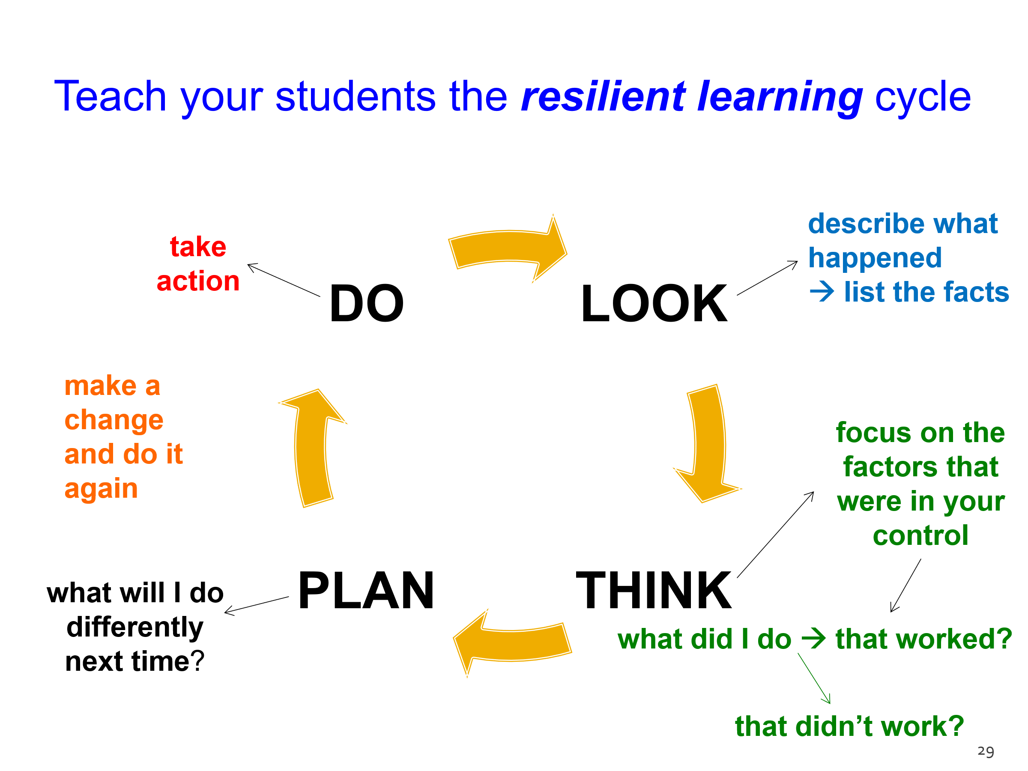

Benefits of competition:
- High performance levels
- Learning to be a good sport:
  - gracious in victory
  - generous in defeat
- Doing a PB - personal best
- Developing self-confidence – comparing self with self and noticing improvements

Competition and the skills of high performance:
- Stay in the moment – “What is happening right here, right now?”
- Mihalyi Csikszentmihalyi – flow states
  - highest possible performance
  - complete absorption
  - in the ‘zone’
    - challenge just beyond what you think you can do
    - skills necessary to do it
- Engage your students with activities that develop deep concentration:
  - reading fiction and non-fiction
  - playing Go, chess, Sudoku, crosswords, Jigsaw puzzles
  - practicing mindfulness, meditation.
- Have them reflect on what a flow state feels like

Identify one opportunity in your own teaching where you could embed a flow state exercise or concentration exercise in your own teaching would be ……….:

- Avoid judgement:
- Avoid competitive assessment, encourage self-assessment in all areas:
  - Only assess them against themselves
  - Support them in achieving a PB – in everything
  - Teach students how to accurately judge the quality of their own output
- When assessing students’ subject work try:
  - asking them to include a self-assessment on what they did well and what they could improve on
  - giving them feedback on both their subject work and the quality of their self-assessment

- Control what you can control:

Professor Carol Dweck on Attribution for Success and Failure
Attributing to effort ….  “hard work, persistence, determination…”  - Is linking your student’s success and failure to something over which they have control  - Any test or assessment becomes a measure of progress, an opportunity to learn | Attributing to ability ….  “talent, intelligence, natural ability….”  - Is linking your student’s success and failure to something over which they have no control  - assessment is then often seen as a critical judgment and an opportunity to fail

Developing resilient learners:
- Help students:
  - learn from every failure
  - use self-assessment to build self-confidence
- Focus both praise for achievement and feedback for change on things the child has control over:
  - on observed effort rather than ability
  - on the deliberate use of effective rather than ineffective strategies

As an academic role model do you demonstrate for students to copy:
  - a willingness to challenge yourself and constantly learn new things?
  - the habit of admitting to and learning from all your mistakes?
  - the connection between active learning and success?
    - what does that take?

Task 6: Practicing Courage:
My courage strategy is …

Make sure your students understand the difference between:
- Resilience
  - Overcoming failure
    - Getting back up again after you fail
- Self-motivation
  - Overcoming procrastination
    - Doing something you don’t want to do
- Courage
  - Overcoming fear
    - Doing something you are afraid of

Developing Affective 21st C skills:
- Lend themselves to a thematic approach
  - E.g. theme of mindfulness, resilience, concentration
  - focused on across the whole school for certain periods of time – 1 or 2 themes per semester?
- Highlighting with video clips, posters, slogans
- Inviting role models, guests to speak
- Having students practice affective skill strategies
- Noticing and celebrating any and every student example of the particular theme

Task 5: Describe what you could do to build Affective 21st C skill development into your teaching:
- Self-confidence
- Resilience
- Failing well
- Flow
- Self-assessment
- Attributing success and failure to controllable factors
- Courage

Cognitive 21st C skills for academic success:

Ways of Thinking
Verbal | Non-Verbal
- words  - logic  - ‘one step at a time’ thinking  - self-talk  - analysing  - phonetic memory  - detail first | - pictures  - guesses  - ‘all at once’ thinking  - imagination  - synthesising  - visual memory  - big picture first
Turning those ideas into reality | Generating ideas that don’t yet exist
Good problem solving requires both ways of thinking

VAK and ‘learning style’

thinking in: |  | tick the box | totals
pictures | Visual
sounds | Auditory
feelings | Kinesthetic

VAK Teaching Strategies:
Visual: use video, film, photographs, use colour on the board, notes, highlighting key points in text, pictures, posters, diagrams and graphs, using mindmaps, using visualisation, using gestures, facial expressions, creating flowcharts of processes, video-based websites

Auditory: reading out loud, playing podcasts, playing quiet instrumental music, talking, describing, dictation, creating discussions or debates, using word games, puns, jokes, asking and answering questions, telling stories, myths, using metaphors, formal and impromptu speeches, inviting in guest speakers, Audio-based websites

Kinesthetic: having the experience, VR & AR, 3D modelling, allowing moving, stretch breaks, role playing, drama, creating question and answer games, field trips, workshop and laboratory sessions, having students teach each other, using real life examples, providing things to touch, pull apart and put together, allowing for physical comfort, thirst, hunger, visiting museums, exhibitions

Teaching strategies for understanding and recall:
- Multi-sensory learning is always the best for all students
- Multi-sensory teaching engages all ‘learning styles’
- Make sure in every lesson that all the key points are represented to the students as:
  - something to see and
  - something to hear and
  - something to do

Memory works best:
- by connection and association
- through all senses
- in patterns
- through staged review

Get your students memories up to 100%
- Start every lesson with a closed-book review of the previous lesson – drawn from students
- Finish each lesson with a 5 minute review of the key points – drawn from students
- Once a week students make a summary of that week’s key points
- Once a month they put 4 weekly summaries together into a one-month summary
- Look over all the one month summaries and chose the best one to laminate and put into a ‘book’ of monthly summaries.
By doing this you have reinforced memory of all the key points in your subject as well as created a content summary resource in your subject that students can look at anytime to help them remember work they have done previously

Memory research findings:
1) Re-reading doesn’t produce good memory, self-testing does. Have students read a section, pause, ask themselves a question, check with the text, move on.
Questions like:
- what are the key points in what I have just read?
- how does this new material connect to what I already know?
- what do I understand now about this that is new for me?
2) Making their own notes in their own words significantly increases your student’s memory for that information - works much better than copying your or the textbook’s notes.
3) Once they understand, remembering becomes easy. Understanding comes from explaining ideas, concepts, facts – in their own words..

If your aim is understanding and memory
- You need to create opportunities for students to put concepts, facts and ideas into their own words:
  - in class
  - for homework
    - the most useful homework for retention and understanding is for students to go over the day’s work and re-write the key ideas in their own words
      - and create questions to ask you the next day about anything they don’t yet understand
- What opportunities could you create in your teaching to have students describe your subject content in their own words?

Task 6: Making memorable summaries – teaching critical thinking:
- Watch the clip A Child’s Temperament That Can Be Mistaken for High Self-Esteem and make a summary of key points using your most preferred method:

Task 7: Evaluate the effectiveness of your won summarising method:
- Work with a partner, using your summary, explain the key points you took out of the video
- Swap, listen to your partner
- Add anything you missed to your own summary
- Rate the effectiveness of your own note-making method
- How could you teach effective summarising in your own lessons?
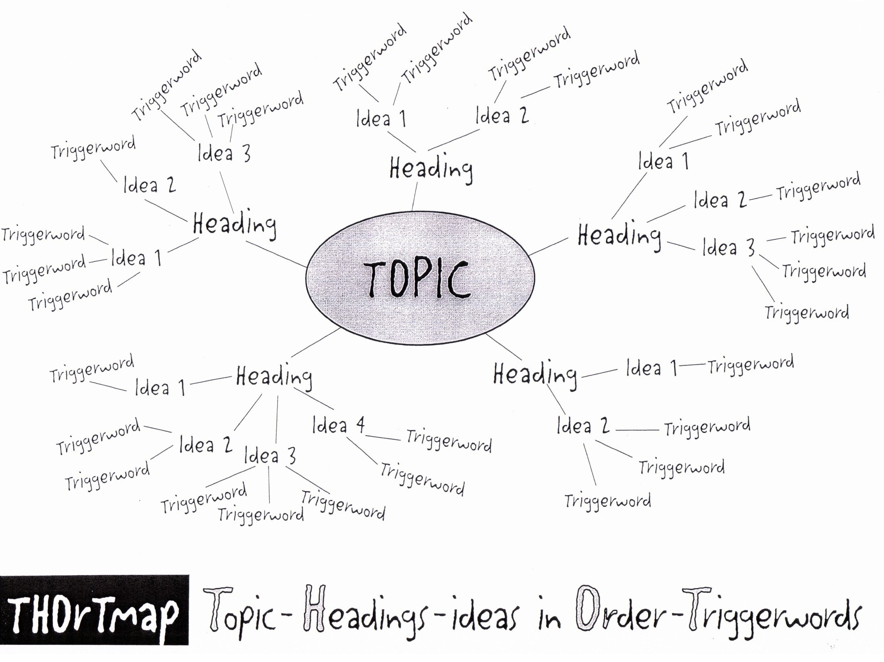

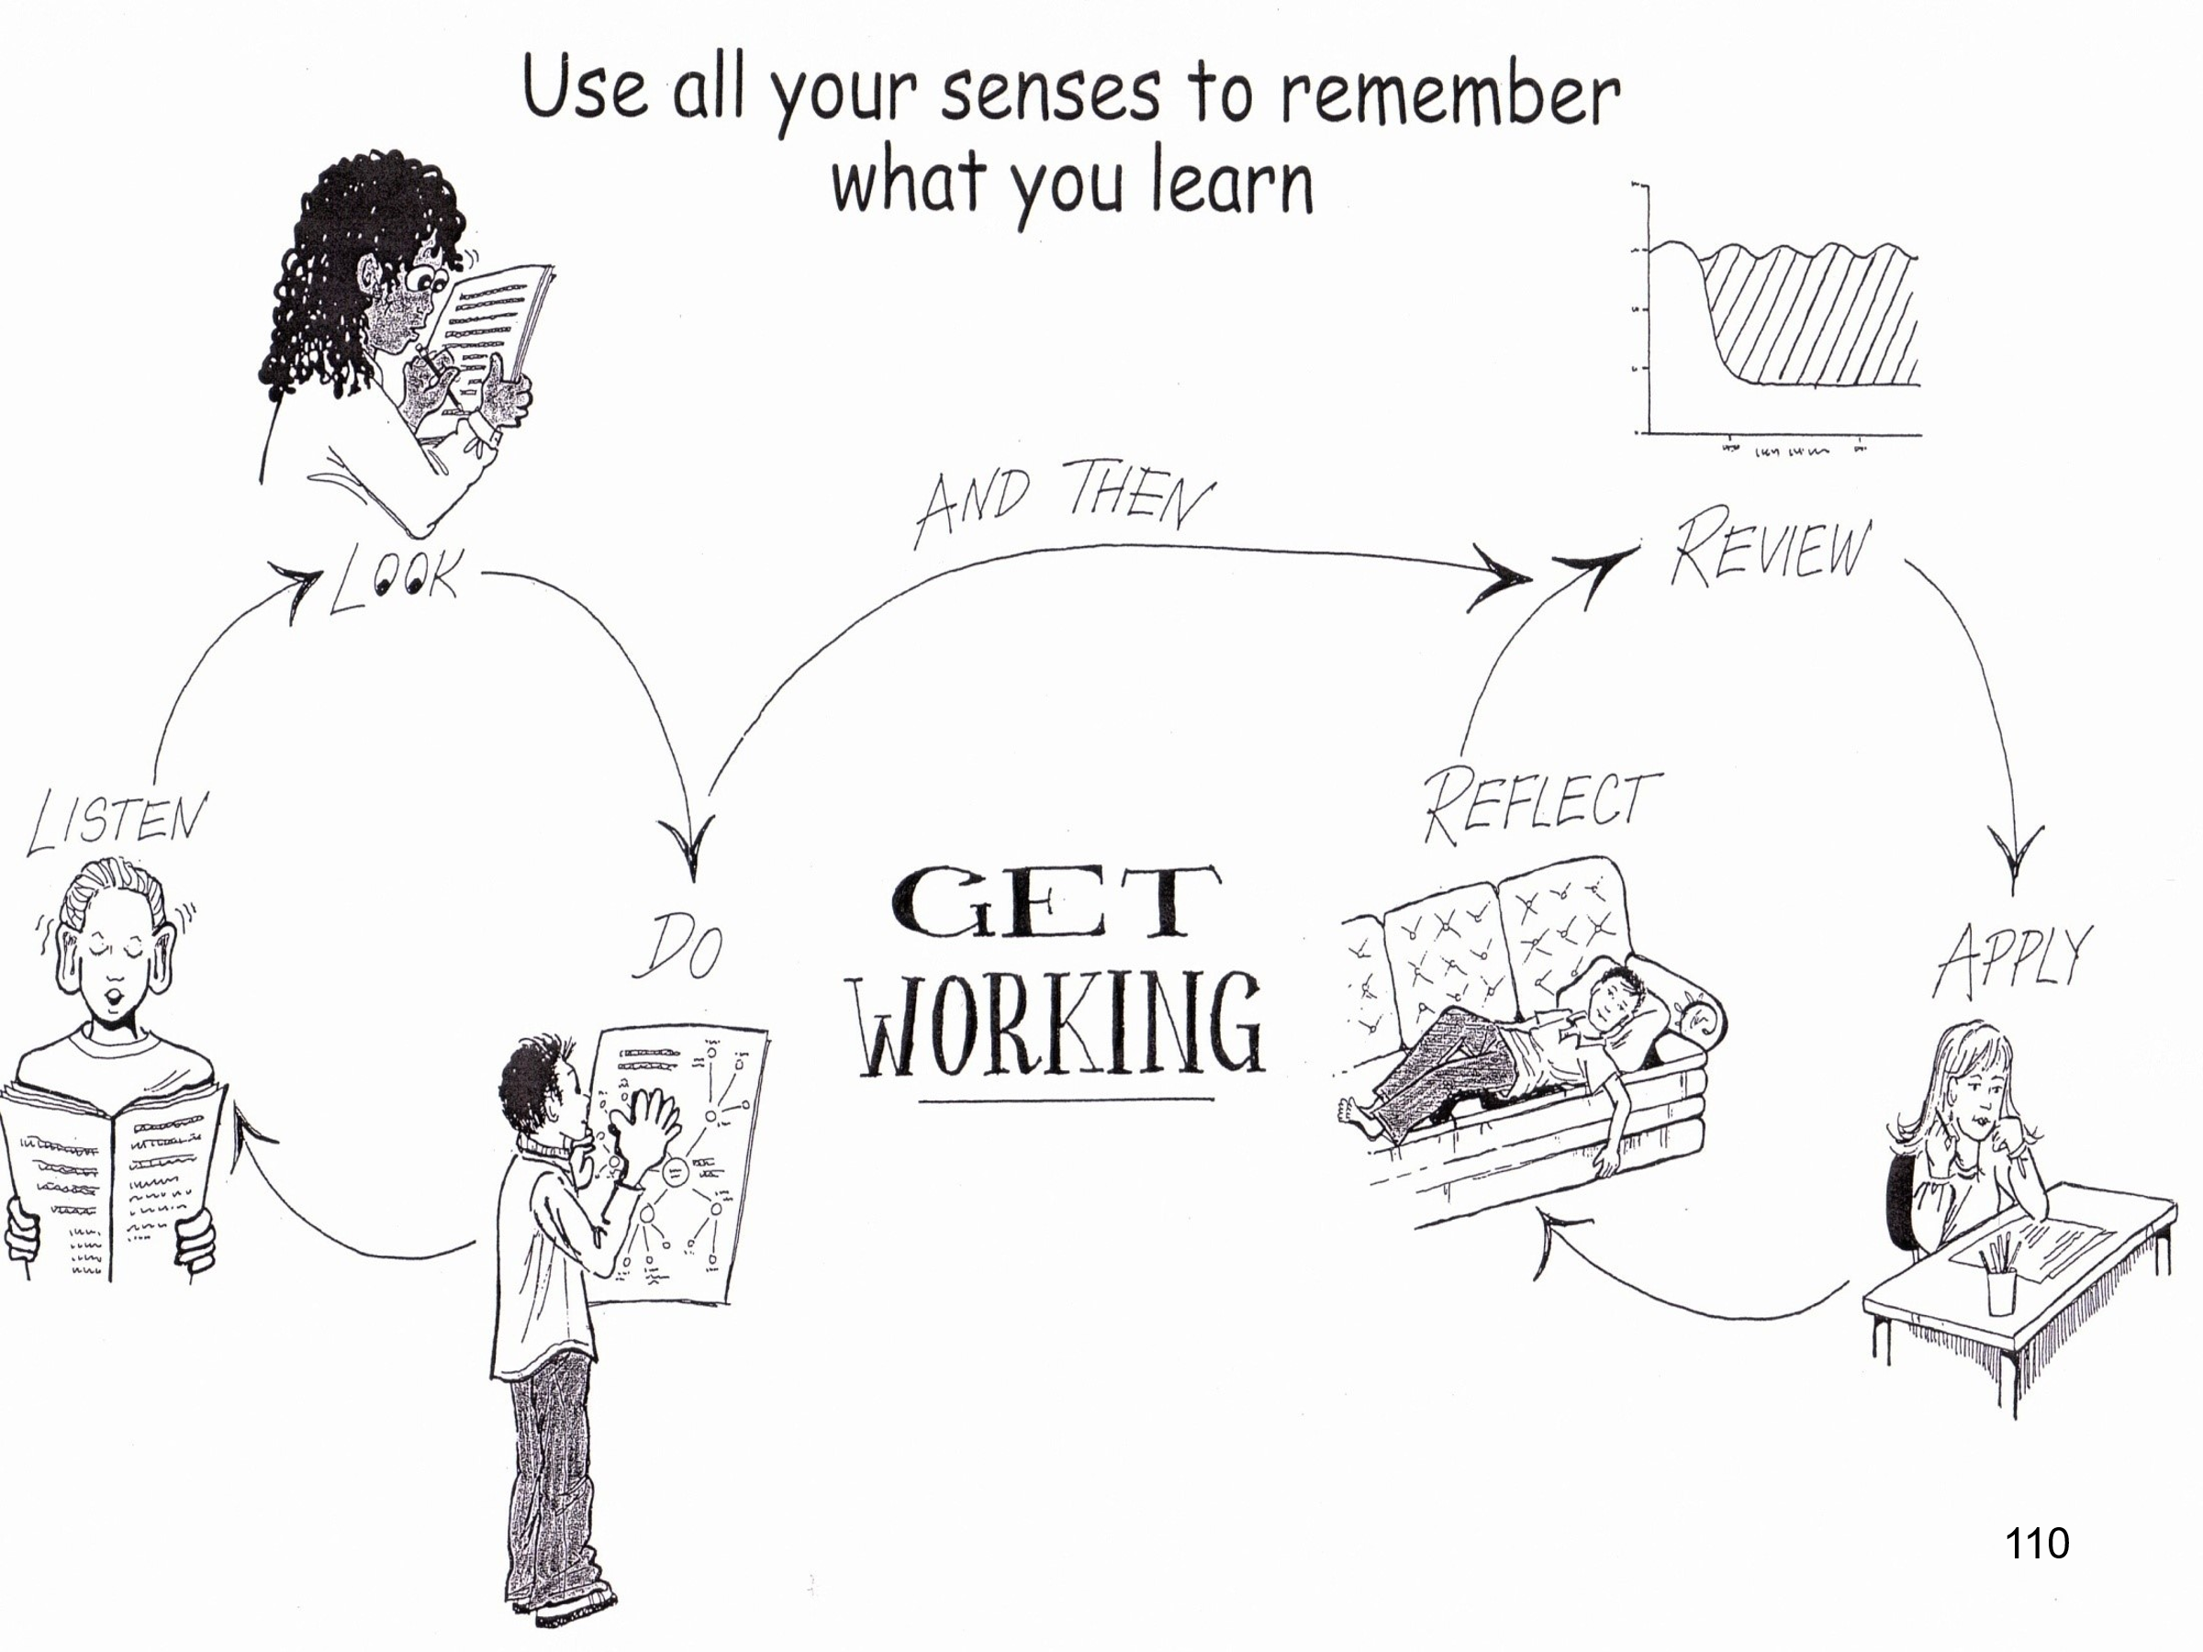

Teach Effective Summarising, Memorising and Note-Making – using THOrTmaps:
Step 1 - Decide how many pages to summarise tonight. Skim read every page – only 5 seconds per page, make sure you look at every word.
Step 2 - Write the first main TOPIC in the middle of a clean page (landscape). Add to it all the HEADINGS, as branches – a maximum of 5 Headings per THOrTmap.
Step 3 - Back to the first page of the notes. Actively read the material now, search for the TRIGGERWORDS - and highlight them. Only one or two Triggerwords per sentence.
( LOOK Step )
Step 4 – Group the TRIGGERWORDS around key IDEAs and attach the Ideas to the Headings in Order.
( DO Step )
Step 5 – When you have finished, add in colour and small pictures, diagrams, cartoons to maximise the sensory connections with the information.
Step 6 - Pick up your completed THOrTmap and out loud, turn your THOrTmap back into sentences, Explain it to yourself, in your own words.
( LISTEN Step )
Step 7 - For any parts you don't yet understand, go back to the book or the notes and pull out a few more words to add to your THOrTmap. Explain that part to yourself again.
Step 8 – After a 10 minute break, look at your THOrTmap again and out loud, turn your THOrTmap back into sentences. Explain it to yourself, in your own words. If there are still parts you don’t remember or understand repeat Step 7.
( 10 Min Review )
Step 9 – Within 24 hours look at your THOrTmap again and explain it to yourself again, in your own words. If necessary repeat Step 7.
( 1 Day Review )
Step10 – Do another review the same as Step 9 after one week.
( 1 Week Review )
Step 11 - Do another review the same as Step 10 after one month.
( 1 Month Review )
Step 12 - Find an old exam question on the topic you have studied and do it without referring back to your notes. Check your answer with your notes
( Apply Step )
Step 13 – Keep a record of which study techniques work best in which subjects - for you. Where, when, how, with whom, using what resources. This is your own personal way of learning. Do more of what helps, less of what doesn’t help.
( Reflect Step )

Help your students overcome exam anxiety:
- remember or imagine feeling confident – see it, hear it, feel it
- lock in the feeling with a clenched fist
- practice once a day for 21 days
- then, when you need to feel confident, just clench your fist – in the same way

Thank you for your participation.

Email me anytime with questions – lance@taolearn.com

All the best,
Lance King

