ATL SKILLS FOR OUR POST-COVID,
AI-ENHANCED,
DIGITAL WORLD:

Lance G. King

lance@taolearn.com
www.taolearn.com
Lance King

ATL SKILLS FOR OUR POST-COVID, AI-ENHANCED, DIGITAL WORLD

Positives of the pandemic:
- 20% of students improved their academic performance
  - All these students were great self-managed learners – with all the skills necessary for success in the post-Covid, digital world

By 2030:
- Automated cars, buses, taxis, trains, aircraft, food delivery, doctor’s visits, banking, law, most retail
- Artificial Intelligence involved in all aspects of life
- Most employment will be freelance – on-line collaborative teams working on specific projects
- Selection for employment in work teams will be based on skills and experience and driven by Social Media
- Social Media identity will be as important as real-life identity
- Highest paid skills will be research, analysis, finding the truth, predicting trends, adapting, creating and problem solving

“The world economy no longer rewards people just for what they know, the world economy rewards people for what they can do with what they know” - Andreas Schleicher, PISA, OECD

Purpose of any ATL skills programme:
- To develop self-managed learners:
  - by teaching all students a full curriculum of ATL skills
  - by having students use their ATL skills to improve their academic performance in all their school subjects
  - by giving students increasing practice in the management of their own learning from Gd 1-12
- To help students realise that they do have control over their own success at school and beyond

Any ATL skills programme is all about focusing students on factors to improve their success that are in their control.

Declining future population predictions for South Korea:
Fewer children in school means more resources for each one:
- Smaller class sizes
- More individual attention from teachers
- Better access to technology and extracurricular activities
- With AI technologies being integrated, children will benefit from highly personalised and adaptive teaching tailored to each individual’s learning abilities and disabilities.
- More places available in universities
- More jobs available
- Increased individual tax burden
- Increased financial burden on each child for support of own extended family
- Increased urgency for today’s children to succeed in school
- Increased need to pursue high paying careers over life enjoyment
To future-proof your students, schools in South Korea will need to:
- Teach every child a full curriculum of mental health skills focused on developing emotional intelligence, resilience, self-care and self-motivation
- Encourage collaboration over competition in learning environments, measure students progress against themselves, develop self-assessment
- Use AI systems to help identify students showing signs of mental health issues early on and alert teachers or counsellors for support.
- Provide comprehensive mental health services within schools to ensure early intervention for students facing any mental health problems.

ATL – all the skills necessary to future-proof your students
- Metacognitive ATL skills for self-awareness
- Cognitive ATL skills for academic success
- Affective ATL skills for mental health

Start with teaching Resilience:
Help students notice their own physical resilience:
    - When they bounce back from adversity
    - Everyone does it sometimes:
      - PE, sports and other physical activities
      - Learning to cope with a new culture, school, country, language
    - Help them to notice resilience – in themselves and in others

"All the top academic students had learned how to fail well
whereas all the lowest academic students were failing badly"

Reactions to failure
Failing Well | Failing Badly
- Acknowledge your failure,  - take responsibility for all the factors that were in your control  - work out what you could have done better  - make changes, and  - do it again, and again if necessary  - but do it differently, every time | - Blame the school or the ‘system’  - Blame other people  - Pretend there is no failure  - Add ‘drama’ to failure to avoid dealing with it  - Avoid any activity that could possibly lead to failure
Full article available at www.taolearn.com/wp-content/uploads/articles/article88.pdf

On receiving poor test results, what do your students do next?
Fail badly - blame the school, the teacher, the weather, their own character
Fail well - rewrite the answers to all the questions they got wrong
  - check back with you to make sure they have got the right answers now
  - ask you what they can do to improve

Helping students learn how to fail well
1. Before any assessment - get students to set their own goals for the outcome
2. After the assessment - have a conversation about the difference between failing well and failing badly
- Teach them the resilient learning cycle
- Build in class time for the re-processing of every mistake
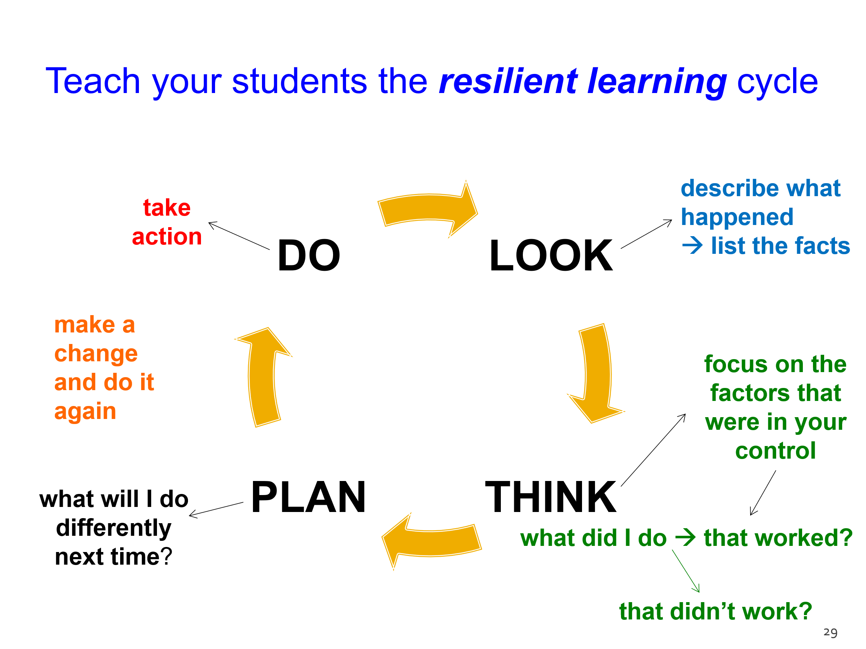

Three key phases of ATL skill proficiency development:
- Competence - student copies skill and learns ‘how best’ to use the skill with simple content
- Practice - Student then practices using the skill with subject content of increasing complexity and works towards being able to use the skill whenever needed
- Mastery - Student can use the skill independently of the teacher and the classroom

ATL PD1 - Mapping learning challenges
- Get into grade level groups
- Each group - discuss what are the most significant academic, social and emotional challenges for students in your grade
- Put all the challenges into a priority order depending on how much each one effects student learning
- Decide on your top 5-10
- Write your grade level at the top of one A1 page, then list your top learning challenges and pin it on the wall – in sequence

ATL PD2: Mapping ATL skills to match learning challenges
- In pairs, pick one learning challenge, discuss what the specific ATL skill(s) would be that would help a student to overcome that challenge – what do they need to learn how to do?
- Think about when a student would need to learn that particular ATL skill in order to be ready to use it when needed
- Write the ATL skill strand on a Post-it note and stick it on the appropriate grade page – when it needs to be learned.
- Repeat
- Be very precise about exactly what skills are needed – exactly what does a student need to learn how to do to succeed in each learning challenge?

ATL PD3: Top 10 ATL Skills for your Grade level:
- Take your Grade level page off the wall
- Analyse all the Post-it notes on your page, eliminate duplication
- Decide on the Top Ten ATL skill strands for your year
- Write them on a new page, put the page back on the wall
- Now you have the beginnings of a plan, next step is to decide:
  - Who, when, where & how?

Two steps to teaching ATL skills:
- Explicit Teaching:
- Designing parts of lessons or whole lessons or homework exercises to specifically teach an ATL skill strand
- Developing ATL skill strand Competence using simple content
- Implicit Teaching:
  - Having students Practice their ATL skills in inquiry-based subject lessons
  - Developing and improving ATL skill competence up to Mastery level by using them with subject content in subject lessons

Where will the time come from?
- Developing student Competence in the ATL skills they need takes teaching time – where will this come from?
  - Within the existing timetable?
    - Taking time out of existing lessons?
    - Taking home-room time?
  - Outside the existing timetable?
    - As homework exercises
    - In an after-school ‘learning skills’ class?

Part 1 – Explicit teaching of ATL skills:
- What if – every student had a one-hour/week ‘ATL Skills’ lesson in their timetable?
  - The ATL Skills program could be aligned with student development so all students develop Competence in all the cognitive, metacognitive, social and emotional ATL skills they need when they need them
  - The purpose of the ATL Skills lessons would be for students to learn ‘how best’ to use each ATL skill
  - Each student would learn the ATL skills they need, when they need them, to cope with the learning, social and emotional challenges they face

Part 2 – Implicit teaching of ATL skills:
- Then students can practice and improve their ATL skills in normal subject lessons.
- Teachers can feel confident that students will already have some competence in all the ATL skills they need to cope with the learning challenges in the classroom
- Teachers will feel encouraged to use more inquiry-based teaching, problem-based teaching, experiential learning, independent and remote learning
- Students will use their ATL skills to learn all their subjects more effectively and more efficiently
- Students will master all the ATL skills they need for their future education, job, career and business success

Who knows best what the learning challenges facing students are?
- Try asking each new year group:
  - “Last year, what did you have to learn how to do, to cope with all the learning expected of you?”
- and then pass that information on to the previous year’s teachers.
- That can be the foundation of your explicit ATL skills teaching program.
- Or the content of a volunteer, students “learning skills” after school club (ongoing CAS project?)

ATL PD4: Mapping the development of skill Competence
- Stay in your year level groups, work in pairs, divide up your Top Ten ATL skills between the group
- Each pair do your research, find out how other people practice, coach or ‘teach’ your particular ATL skill strand
- Design one age appropriate exercise any teacher could use to introduce the skill to the students for the first time using any content to develop Competence
- Then design one exercise you could use to have students Practice this skill in one of your own subject classes
- Write the skill and both exercises into your grade level spreadsheet

See exercises in my Korean language ATL skills student workbooks available at: https://www.hakjisa.co.kr/subpage.html?page=book_book_info&bidx=6425
See Professor Ko’s ATL exercises at https://teachercanvassador.my.canva.site/tribes-atls

Truth and AI – key ATL skill set:
- Understanding the limits of large language-based models – predictive text only
- Finding credible, well referenced ai – Perplexity.ai
- Asking good research questions – drilling down, questions within questions
- Verifying the truth – going to primary sources
- Being wary of hallucinations – triple fact checking
- Constructing evidence-based arguments
- Re-writing, finding your own flow/style

To develop self-managed learners:
- Teachers must learn how to limit ‘teaching’ and allow self-managed learning to take place
- Only by being allowed to practice the skills of self-managed learning will students become effective self-managed learners

Pre-suppositions of school-based education (for at least the last 3500 years):
- Learning means gaining knowledge and understanding in different subject disciplines
- Learning is hard work
- Children are best organized to learn by age
- What to learn, where to learn, when to learn and how to learn are all determined by teachers
- Teachers set and mark all assessments and exams
- Students’ success is determined by performance in summative assessments

Everything is about to change:
“In 3-4 years the very best personalised expert is going to be available to hundreds of millions of people. The cost of accessing the best information in the world, in a personalised way, is about to plumet to absolute zero.” Mustafa Suleyman, CEO of Microsoft AI.

- AI systems will serve as personalized, always-available tutors, mentors, teachers and companions.
- AI-driven teaching platforms will monitor every student’s progress, identify learning gaps in real-time, and adjust teaching strategies to suit each learner’s pace and style.
- These platforms will go beyond subject knowledge, integrating cognitive and metacognitive development, teaching students how to think, reflect, and learn independently, efficiently and effectively.
- AI systems will learn the appropriate responses to be able to mimic emotional intelligence and will be able to develop nuanced responses to students’ moods and social challenges.
- AI companions will be able to engage in meaningful conversations, offering encouragement and emotional support.
- Teachers in schools will take on a care-taking role, monitoring attendance and progress
- Teachers will become nurturers of relationships, focusing on students' emotional resilience and mental health. Their role will involve checking in with students regularly, ensuring they feel socially connected and understood—not by a machine but by a human being.

IF:
- AI becomes superior in all aspects of teaching and learning - cognitive, social, and emotional, and if
- there are available, ethical, trusted, safe AI-tutors for children to interact with - at this deep level
then…

- Subject teaching will become the domain of AI
- Resulting in a demand for ‘learning-process teachers’ to help students:
  - interact with the learning systems and media they are using
  - maximise the efficiency and the effectiveness of their learning
  - maintain mental health
- All teachers will become ATL teachers!!

Thank you for your participation.
Email me anytime with questions – lance@taolearn.com

All the best,
Lance King

